

**Capstone Project Report**

**Report 3 – System Requirement Specification**

– Ho Chi Minh, July 2021 –

**Table of Contents**

I. Project Report 3

1. Status Report 3

2. Team Involvements 3

3. Issues/Suggestions 3

II. System Requirement Specification 4

1. Overall Description 4

1.1 Product Overview 4

1.2 Business Rules 5

2. User Requirements 6

2.1 Overview 6

2.2 <<Feature Name 1 – i.e Order Meals>> 7

2.3 <<Feature name 2 – i.e: Meal Subscriptions>> 10

2.4 <<Next Feature Name..>> 11

3. Functional Requirements 12

3.1 System Functional Overview 12

3.2 <<Feature Name 1>> 13

3.3 <<Feature Name 2>> 14

4. Non-Functional Requirements 15

4.1 External Interfaces 15

4.2 Quality Attributes 16

5. Other Requirements 18

5.1 Appendix1 - Messages List 18

5.2 Appendix2 - … 18

# I. Software Requirement Specification

## 1. Overall Description

* Mumbi can create a form for users (specifically the mothers) to provide their information. Users can give their pregnancy status, child’s information, or father’s information in that form.
* After that, Mumbi creates a family tree for users based on the information they provide.
* Mumbi provides users with vaccination schedules for each child previously registered for vaccination.
* Mumbi also create a calendar for users to manage their pregnancy by the information gave to Mumbi by mothers
* Mumbi can build a development chart for a kid by the information which was given by users, users can follow the development index on the chart to figure out what is good for their children.
* Weight, height, and teeth condition are all included in the development chart.
* Mumbi can build a small community for mothers to share their experiences with others, also the lovely moments of their child by diary feature.
* Mumbi has daily news and some guidebooks that users can watch and know about a child’s care and what nutrition is needed.

## 2. User Requirements

### 2.1. Overview

### 2.1.1. Use Case Diagram

Source: [Use Case Overall](https://drive.google.com/file/d/1if03ipQTBqkjxPD3ok7IkRmvnzJ5zy3H/view?usp=sharing)

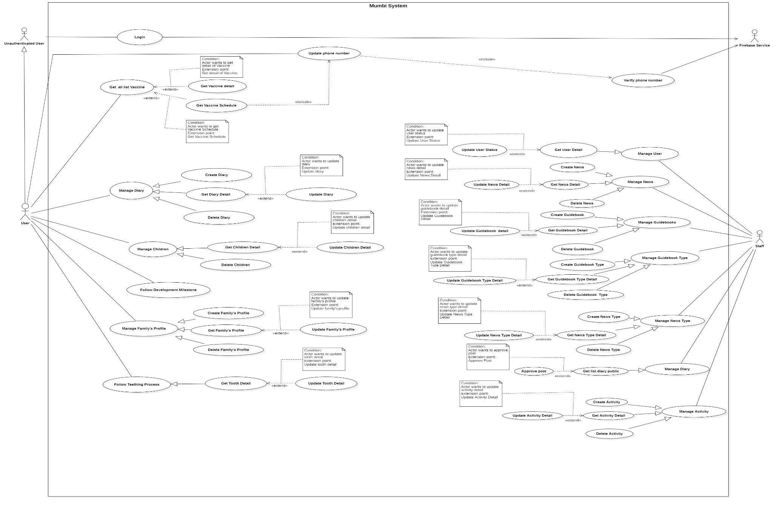

Figure 2 - System Overview Use Case Diagram

### 2.1.2. System Actors

|  |  |  |
| --- | --- | --- |
| **No.** | **Actor** | **Description** |
| **1** | Unauthenticated User | A guest can log in to the system to become a user. |
| **2** | User | The user can use every utility of the application. |
| **3** | Firebase Service | Firebase Service supports sending notifications. |
| **4** | Staff | The staff manages and follows the user, news, guidebooks, approved posts, type of news, type of guidebook, action. |

Table 9 - System Actors

### 2.1.3. Use Cases List

|  |  |  |  |
| --- | --- | --- | --- |
| **ID** | **Use case** | **Primary Actors** | **Secondary Actors** |
|  | [Login](https://docs.google.com/document/d/1xhLb5dCqexeui3QgkQ-JR-Q5CwQ9WU3k/edit#bookmark=id.gjdgxs) | Unauthenticated User |  |
|  | [Update Phone number](https://docs.google.com/document/d/1xhLb5dCqexeui3QgkQ-JR-Q5CwQ9WU3k/edit#bookmark=id.30j0zll) | User | Firebase Service |
|  | [Get all list Vaccine](https://docs.google.com/document/d/1xhLb5dCqexeui3QgkQ-JR-Q5CwQ9WU3k/edit#bookmark=id.1fob9te) | User |  |
|  | [Get Vaccine detail](https://docs.google.com/document/d/1xhLb5dCqexeui3QgkQ-JR-Q5CwQ9WU3k/edit#bookmark=id.3znysh7) | User |  |
|  | [Get Vaccine Schedule](https://docs.google.com/document/d/1xhLb5dCqexeui3QgkQ-JR-Q5CwQ9WU3k/edit#bookmark=id.2et92p0) | User |  |
|  | [Create Diary](https://docs.google.com/document/d/1xhLb5dCqexeui3QgkQ-JR-Q5CwQ9WU3k/edit#bookmark=id.2s8eyo1) | User |  |
|  | [Get Diary Detail](https://docs.google.com/document/d/1xhLb5dCqexeui3QgkQ-JR-Q5CwQ9WU3k/edit#bookmark=id.17dp8vu) | User |  |
|  | [Update Diary](https://docs.google.com/document/d/1xhLb5dCqexeui3QgkQ-JR-Q5CwQ9WU3k/edit#bookmark=id.3rdcrjn) | User |  |
|  | [Delete Diary](https://docs.google.com/document/d/1xhLb5dCqexeui3QgkQ-JR-Q5CwQ9WU3k/edit#bookmark=id.26in1rg) | User |  |
|  | [Get Children Detail](https://docs.google.com/document/d/1xhLb5dCqexeui3QgkQ-JR-Q5CwQ9WU3k/edit#bookmark=id.lnxbz9) | User |  |
|  | [Update Children Detail](https://docs.google.com/document/d/1xhLb5dCqexeui3QgkQ-JR-Q5CwQ9WU3k/edit#bookmark=id.35nkun2) | User |  |
|  | [Delete Children](https://docs.google.com/document/d/1xhLb5dCqexeui3QgkQ-JR-Q5CwQ9WU3k/edit#bookmark=id.1ksv4uv) | User |  |
|  | [Create Family’s Profile](https://docs.google.com/document/d/1xhLb5dCqexeui3QgkQ-JR-Q5CwQ9WU3k/edit#bookmark=id.2jxsxqh) | User |  |
|  | [Get Family’s Profile](https://docs.google.com/document/d/1xhLb5dCqexeui3QgkQ-JR-Q5CwQ9WU3k/edit#bookmark=id.z337ya) | User |  |
|  | [Update Family’s Profile](https://docs.google.com/document/d/1xhLb5dCqexeui3QgkQ-JR-Q5CwQ9WU3k/edit#bookmark=id.3j2qqm3) | User |  |
|  | [Delete Family’s Profile](https://docs.google.com/document/d/1xhLb5dCqexeui3QgkQ-JR-Q5CwQ9WU3k/edit#bookmark=id.1y810tw) | User |  |
|  | Follow Development Milestone | User |  |
|  | [Create News](https://docs.google.com/document/d/1xhLb5dCqexeui3QgkQ-JR-Q5CwQ9WU3k/edit#bookmark=id.4i7ojhp) | Staff |  |
|  | [Get News Detail](https://docs.google.com/document/d/1xhLb5dCqexeui3QgkQ-JR-Q5CwQ9WU3k/edit#bookmark=id.2xcytpi) | Staff |  |
|  | [Update News Detail](https://docs.google.com/document/d/1xhLb5dCqexeui3QgkQ-JR-Q5CwQ9WU3k/edit#bookmark=id.1ci93xb) | Staff |  |
|  | [Delete News](https://docs.google.com/document/d/1xhLb5dCqexeui3QgkQ-JR-Q5CwQ9WU3k/edit#bookmark=id.3whwml4) | Staff |  |
|  | [Create Guidebooks](https://docs.google.com/document/d/1xhLb5dCqexeui3QgkQ-JR-Q5CwQ9WU3k/edit#bookmark=id.qsh70q) | Staff |  |
|  | [Get Guidebooks Detail](https://docs.google.com/document/d/1xhLb5dCqexeui3QgkQ-JR-Q5CwQ9WU3k/edit#bookmark=id.3as4poj) | Staff |  |
|  | [Update Guidebooks Detail](https://docs.google.com/document/d/1xhLb5dCqexeui3QgkQ-JR-Q5CwQ9WU3k/edit#bookmark=id.1pxezwc) | Staff |  |
|  | [Delete Guidebooks](https://docs.google.com/document/d/1xhLb5dCqexeui3QgkQ-JR-Q5CwQ9WU3k/edit#bookmark=id.49x2ik5) | Staff |  |
|  | Create Guidebook Type | Staff |  |
|  | Get Guidebook Type Detail | Staff |  |
|  | Update Guideboook Type Detail | Staff |  |
|  | Delete Guidebook Type | Staff |  |
|  | Create News Type | Staff |  |
|  | Get News Type Detail | Staff |  |
|  | Update News Type Detail | Staff |  |
|  | Delete News Type | Staff |  |
|  | Create Activity | Staff |  |
|  | Get Activity Detail | Staff |  |
|  | Update Activity Detail | Staff |  |
|  | Delete Activity | Staff |  |
|  | Get User Detail | Staff |  |
|  | Update User Status | Staff |  |
|  | Approve Post | Staff |  |
|  | Verify Phone number | Firebase Service |  |

Table 10 - Use cases list

### 2.2. Unauthenticated User

#### 2.2.1. Login

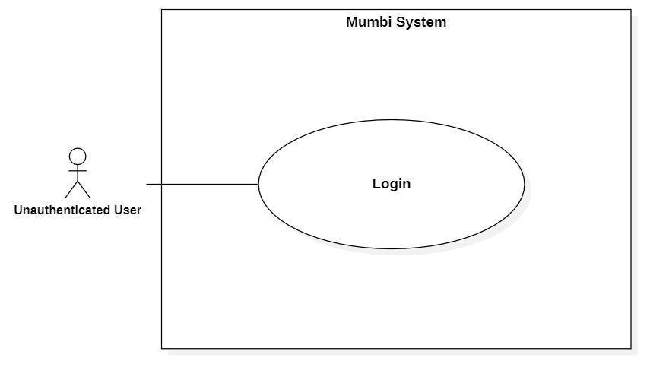

Figure 3 - <Unauthorized User> Login

|  |  |  |  |
| --- | --- | --- | --- |
| **UC ID and Name:** | **Login** | | |
| Created By: | Bui Hai Nam | Date Created: | 18/05/2021 |
| Primary Actor: | Unauthenticated User | Secondary Actors: | N/A |
| Trigger: | The actor wants to log in. | | |
| Description: | The actor uses this feature to log in to the system to use features that need authentication. | | |
| Preconditions: | For the actor who wants to be authorized as a user:  − The actor needs a Gmail account.  − The actor uses a browser that is supported by Firebase Service. For the actor who wants to be authorized as a staff of Mumbi, one needs to have an account in the system. | | |
| Post-conditions: | Success  The actor is authenticated.  Fail  The actor is not authenticated. | | |
| Normal Flow: | |  |  |  | | --- | --- | --- | | **Step** | **Actor Action** | **System Response** | | 1 | The actor wants to log in. | The system requests account information.  **For user:**  The system requests the  actor input Gmail account.  **For a staff of Mumbi:**  The system requests the  actor input Gmail account. | | 2 | The actor inputted information. | **For user:**  The system sends an  authentication request to  Firebase Service. Firebase  Service checks the actor’s  information and  authenticates one.  *[Exception 1]*  **For a staff of Mumbi:**  The system sends an  authentication request to  Firebase Service. Firebase  Service checks the actor’s  information and  authenticates one.  *[Exception 1]* | | | |
| Alternative Flows: | N/A | | |
| Exceptions: | |  |  |  | | --- | --- | --- | | **No** | **Cause** | **System Response** | | 1 | The Gmail account is not valid. | The system requests the actor to try again. | | | |
| Priority: | Medium | | |
| Frequency of Use: | Frequency | | |
| Business Rules: | − Có hai hướng để đăng nhập vào hệ thống.  1. Đăng nhập với vai trò là người sử dụng: dùng email của Gmail để đăng nhập.  2. Đăng nhập với vai trò là nhân viên của Mumbi: dùng email của Gmail để đăng nhập.  **\*English:**  − There are two ways to log in to the system.  1. Log in as a user: use Gmail's email to log in.  2. Log in as a Mumbi employee: use Gmail's email to log in. | | |
| Other Information: | N/A | | |
| Assumptions: | N/A | | |

Table 11 - <Unauthorized User> Login

### 2.3. User

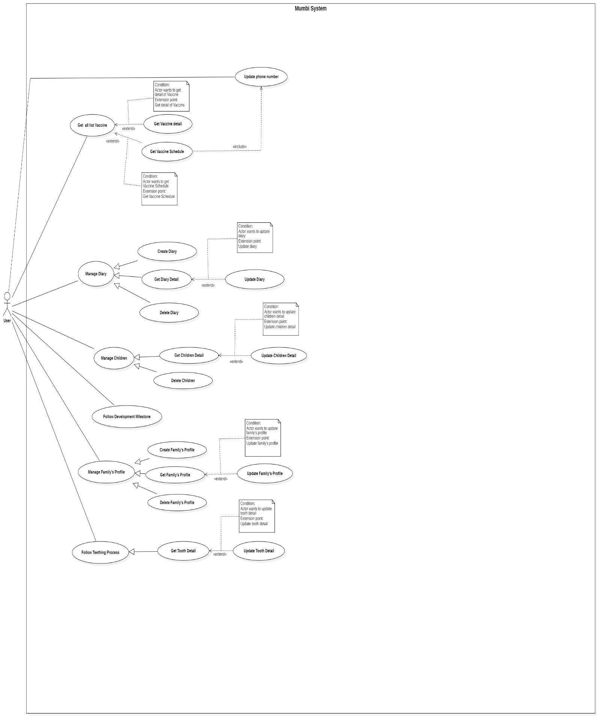

Figure 4 - <User> Overview Use Case Diagram

#### 2.3.1. Update Phone number

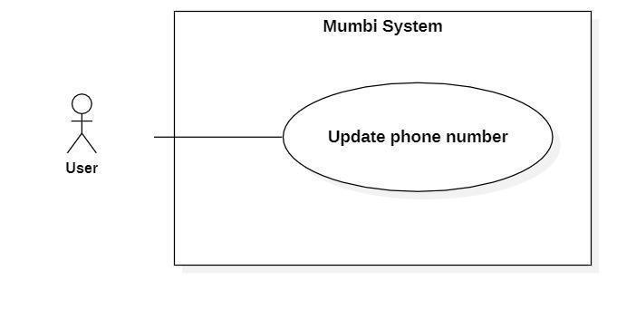

Figure 5 - <User> Update phone number

|  |  |  |  |
| --- | --- | --- | --- |
| **UC ID and Name:** | **Update Phone number** | | |
| Created By: | Do Le Tu Uyen | Date Created: | 19/05/2021 |
| Primary Actor: | User | Secondary Actors: | N/A |
| Trigger: | The actor wants to get information about vaccines. | | |
| Description: | Phone number is required when getting information about vaccines in Mumbi. The phone number may change after time, so this feature allows the user to update phone number in the system. | | |
| Preconditions: | The actor had been authorized as a user. | | |
| Post-conditions: | Success  The new phone number will be updated in the system.  Fail  The system shows an error message. | | |
| Normal Flow: | |  |  |  | | --- | --- | --- | | **Step** | **Actor Action** | **System Response** | | 1 | The actor indicates that needs to update the phone number to get information about vaccines. | The system requests the actor to provide a phone number. | | 2 | The actor inputs the phone  number. | The system receives a phone number.  *[Exception 1]*  The system sends a request to Firebase Service to verify it.  The process as use case Verify Phone Number.  *[Exception 2]*  The system saves the phone number. | | | |
| Alternative Flows: | N/A | | |
| Exceptions: | |  |  |  | | --- | --- | --- | | **No** | **Cause** | **System Response** | | 1 | The actor inputs the wrong  phone number’s format. | The system requests the actor to re-input the phone number. | | 2 | Verify phone number failed. | The system shows error  messages to the actor. | | | |
| Priority: | High | | |
| Frequency of Use: | Regularly | | |
| Business Rules: | − Số điện thoại là một thông tin bắt buộc khi muốn lấy thông tin về Vaccines.  − Số điện thoại có thể thay đổi do đó chức năng này giúp cập nhật lại số điện thoại đã cung cấp cho hệ thống.  − Người dùng cần nhập số điện thoại vào hệ thống. Hệ thống sẽ gửi yêu cầu đến Firebase để gửi mã OTP đến số điện thoại này. Nếu người dung nhập đúng mã OTP, thì hệ thống sẽ lưu số điện thoại mới này. Quá trình cập nhật thành công.  **\*English:**  − The phone number is obligatory when a user wants to get information about vaccines.  − Phone numbers can change, so this function helps to update the phone number provided to the system.  − Users need to enter their phone number into the system. The  system will send a request to Firebase then send an OTP code to this phone number. If the user enters the correct OTP, the system will store this new phone number. The update is successful. | | |
| Other Information: | N/A | | |
| Assumptions: | Số điện thoại còn đang hoạt động và có thể nhận tin nhắn từ Firebase Service.  *English:  The phone number is active and can receive messages from Firebase Service. | | |

Table 12 - <User> Update phone number

#### 2.3.2. Get all list Vaccine

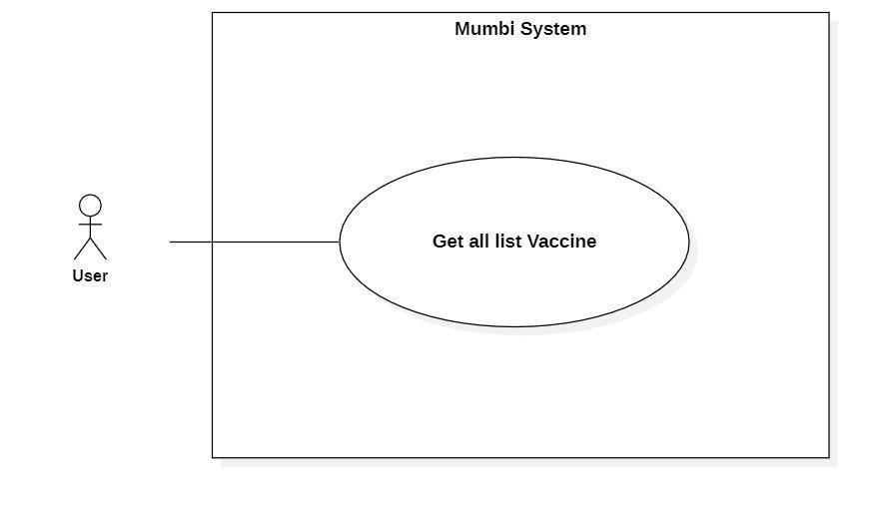

Figure 6 - <User> Get all list Vaccine

|  |  |  |  |
| --- | --- | --- | --- |
| **UC ID and Name:** | **Get all list Vaccine** | | |
| Created By: | Do Le Tu Uyen | Date Created: | 28/05/2021 |
| Primary Actor: | User | Secondary Actors: | N/A |
| Trigger: | The actor wants to get a list of vaccines | | |
| Description: | This feature allows the actor to get a list of vaccines, so that the actor can get the vaccine’s information. | | |
| Preconditions: | The actor had been authorized as a user. | | |
| Post-conditions: | Success  The actor receives a list of vaccines.  Fail  N/A | | |
| Normal Flow: | |  |  |  | | --- | --- | --- | | **Step** | **Actor Action** | **System Response** | | 1 | The actor wants to get a list of vaccines. | The system return list of vaccines includes:   * Name * Antigen * ProducingCountry * Price | | | |
| Alternative Flows: | N/A | | |
| Exceptions: | N/A | | |
| Priority: | Medium | | |
| Frequency of Use: | Regularly | | |
| Business Rules: | − Danh sách các vaccine trả về có giá của từng loại vaccine được cập nhật theo ngày.  − Hiển thị thông tin của vaccine bao gồm:   * Tên vaccine * Bệnh (Kháng nguyên) * Nước sản xuất * Giá tham khảo   **\* English**  − The list of vaccines returned with the prices of each vaccine is updated by date.  − Display detail of vaccine includes:   * Name * Antigen * ProducingCountry * Price | | |
| Other Information: | N/A | | |
| Assumptions: | N/A | | |

Table 13 - <User> Get all list Vaccine

#### 2.3.3. Get Vaccine detail

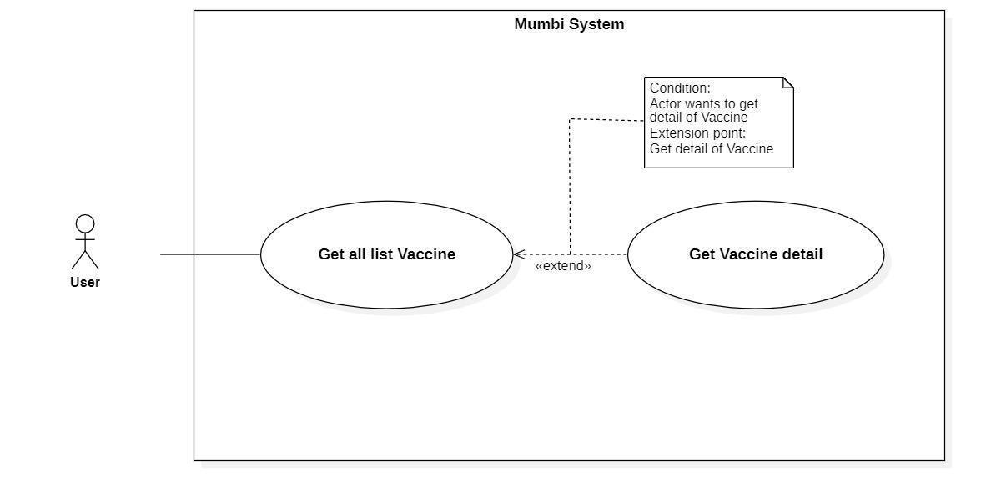

Figure 7 - <User> Get Vaccine detail

|  |  |  |  |
| --- | --- | --- | --- |
| **UC ID and Name:** | **Get Vaccine detail** | | |
| Created By: | Do Le Tu Uyen | Date Created: | 20/05/2021 |
| Primary Actor: | User | Secondary Actors: | N/A |
| Trigger: | The actor wants to get details of the vaccine. | | |
| Description: | This feature allows the actor to get detailed information of a vaccine including name, category, opened/closed date, number of slots, description, status, ... The user uses this information to decide what kind of vaccine should be injected. | | |
| Preconditions: | The actor had been authorized as a user. | | |
| Post-conditions: | Success  The actor receives details of the vaccine.  Fail  N/A | | |
| Normal Flow: | |  |  |  | | --- | --- | --- | | **Step** | **Actor Action** | **System Response** | | 1 | The actor wants to get detail of vaccines. | The system return detail of vaccine includes:   * Name * Antigen * ProducingCountry * Price | | | |
| Alternative Flows: | N/A | | |
| Exceptions: | N/A | | |
| Priority: | Medium | | |
| Frequency of Use: | Frequency | | |
| Business Rules: | - Hiển thị thông tin chi tiết của vaccine bao gồm:   * Tên vaccine * Bệnh (Kháng nguyên) * Nước sản xuất * Giá tham khảo   **\* English**  − Display detail of vaccine includes:   * Name * Antigen * ProducingCountry * Price | | |
| Other Information: | N/A | | |
| Assumptions: | N/A | | |

Table 14 - <User> Get Vaccine detail

#### 2.3.4. Get Vaccine Schedule

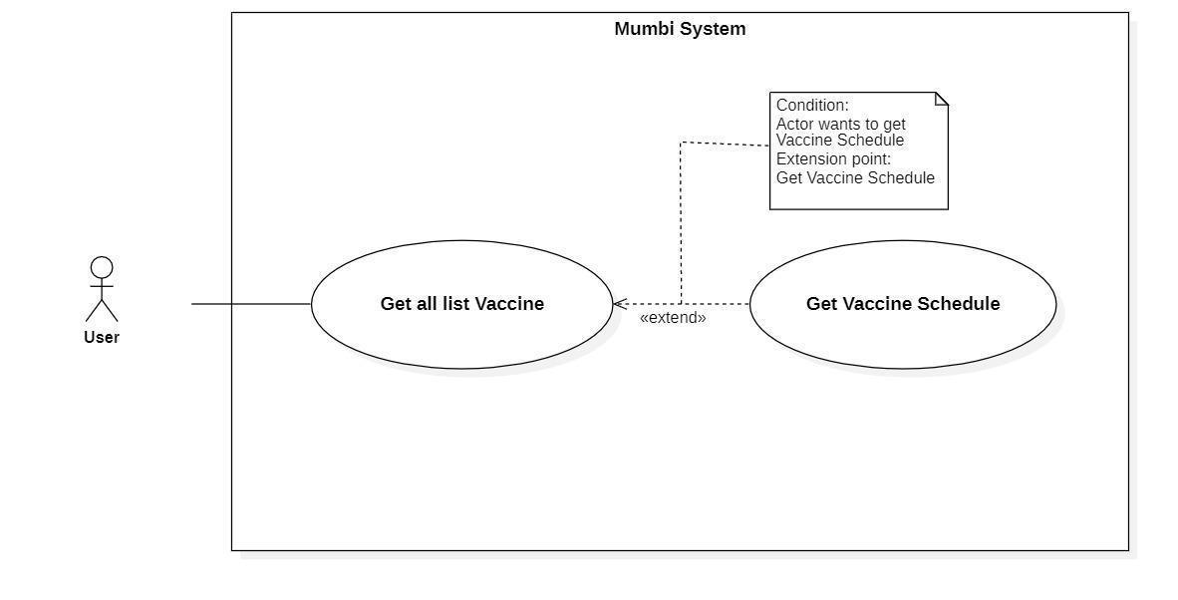Figure 8 - <User> Get Vaccine detail

|  |  |  |  |
| --- | --- | --- | --- |
| **UC ID and Name:** | **Get Vaccine Schedule** | | |
| Created By: | Do Le Tu Uyen | Date Created: | 20/05/2021 |
| Primary Actor: | User | Secondary Actors: | N/A |
| Trigger: | The actor wants to get a vaccine schedule. | | |
| Description: | This feature allows the actor to get a vaccine schedule including vaccine’s name, antigen, injection date, order injection, vaccine batch, vaccine facility, status, … The user uses this information to handle vaccine schedules easily. | | |
| Preconditions: | − The actor must update phone number.  − The actor was authorized as a user.  − The actor added baby or pregnancy information. | | |
| Post-conditions: | Success  The actor receives a vaccine schedule.  Fail  The system shows an error message. | | |
| Normal Flow: | |  |  |  | | --- | --- | --- | | **Step** | **Actor Action** | **System Response** | | 1 | The actor wants to get vaccine schedule. | The system return detail of vaccine includes:   * VaccineName * Antigen * InjectionDate * OrderOfInjection * VaccineBatch * VaccineFacility * Status | | | |
| Alternative Flows: | N/A | | |
| Exceptions: | N/A | | |
| Priority: | Medium | | |
| Frequency of Use: | Frequency | | |
| Business Rules: | - Hiển thị thông tin chi tiết của vaccine bao gồm:   * Tên vaccine * Bệnh (Kháng nguyên) * Ngày tiêm * Mũi tiêm số * Số lô * Cơ sở vaccine * Trạng tháo   **\* English**  − Display detail of vaccine includes:   * Name * Antigen * InjectionDate * OrderOfInjection * VaccineBatch * VaccineFacility * Status | | |
| Other Information: | N/A | | |
| Assumptions: | N/A | | |

Table 15 - <User> Get Vaccine Schedule

#### 2.3.5. Create Diary

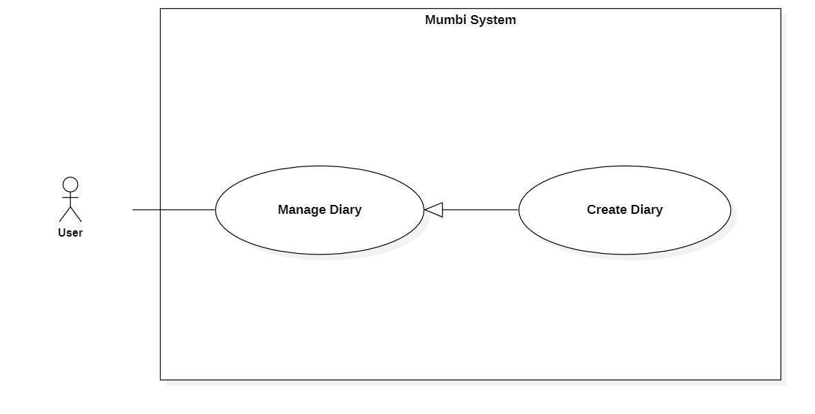

Figure 9 - <User> Create Diary

|  |  |  |  |
| --- | --- | --- | --- |
| **UC ID and Name:** | **Create Diary** | | |
| Created By: | Pham Hoang Duy | Date Created: | 20/05/2021 |
| Primary Actor: | User | Secondary Actors: | N/A |
| Trigger: | The actor sends a request to create a diary. | | |
| Description: | The actor needs to have a diary to capture memorable moments and memories. Therefore, this feature allows the user to create a diary. | | |
| Preconditions: | The actor had been authorized as a user. | | |
| Post-conditions: | Success  A new diary is created.  Fail  The system shows an error message. | | |
| Normal Flow: | |  |  |  | | --- | --- | --- | | **Step** | **Actor Action** | **System Response** | | 1 | The actor sends a command to create a diary. | The system displays information of diary to create:   * Image * DiaryContent | | 2 | The actor fills in information about the diary. | The system receives information, create a new diary. | | | |
| Alternative Flows: | N/A | | |
| Exceptions: | N/A | | |
| Priority: | Medium | | |
| Frequency of Use: | Frequently | | |
| Business Rules: | − Nhật ký sẽ giúp người dùng lưu lại những khoảnh khắc và kỷ niệm đáng nhớ trong suốt quá trình mang thai cũng như nuôi dạy bé.  − Quy trình tạo nhật ký:   * Điền và lựa chọn các thông tin cơ bản của nhật ký như hình ảnh, nội dung nhật ký. * Kiểm tra lại thông tin và gửi yêu cầu tạo một nhật ký mới đến hệ thống.   − Nhật ký bao gồm những trường sau:   * Hình ảnh * Nội dung nhật ký   **\*English**  − The diary will help users save memorable moments and memories during pregnancy and raising babies.  − The process of creating a diary:   * Fill in and select the basic information of the diary such as diary content, image. * Check the information and send a request to create a new diary to the system.   − Diary includes following fields:   * Image * DiaryContent | | |
| Other Information: | N/A | | |
| Assumptions: | N/A | | |

Table 16 - <User> Create Diary

#### 2.3.6. Get Diary Detail

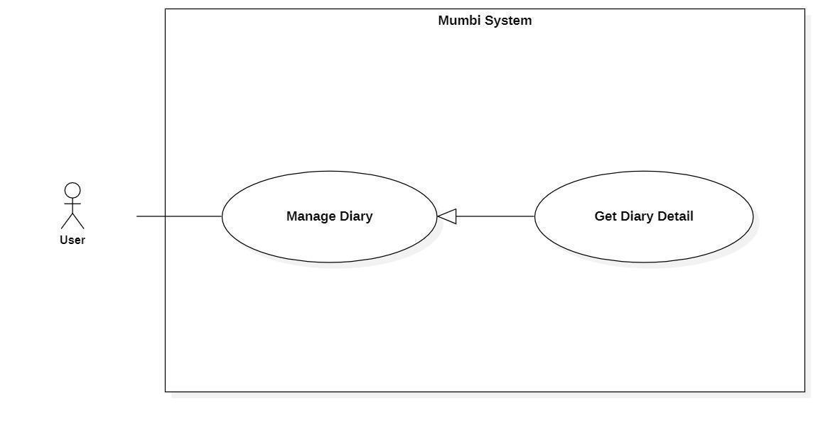

Figure 10 - <User> Get Diary Detail

|  |  |  |  |
| --- | --- | --- | --- |
| **UC ID and Name:** | **Get Diary Detail** | | |
| Created By: | Pham Hoang Duy | Date Created: | 20/05/2021 |
| Primary Actor: | User | Secondary Actors: | N/A |
| Trigger: | The actor wants to get the details of the diary. | | |
| Description: | This feature allows the actor to get detailed information of a diary including diary content, image. The user uses this information to make sure that every information is exactly. | | |
| Preconditions: | The actor had been authorized as a user. | | |
| Post-conditions: | Success  The actor receives detail of diary.  Fail  N/A | | |
| Normal Flow: | |  |  |  | | --- | --- | --- | | **Step** | **Actor Action** | **System Response** | | 1 | The actor wants to get the details of the diary. | The system return detail of diary includes:   * DiaryContent * Image * PublicDate | | | |
| Alternative Flows: | N/A | | |
| Exceptions: | N/A | | |
| Priority: | Medium | | |
| Frequency of Use: | Frequency | | |
| Business Rules: | - Hiển thị thông tin chi tiết của nhật ký bao gồm:   * Hình ảnh * Nội dung nhật ký * Ngày đăng   **\* English**  − Display detail of diary includes:   * DiaryContent * Image * PublicDate | | |
| Other Information: | N/A | | |
| Assumptions: | N/A | | |

Table 17 - <User> Get Diary Detail

#### 2.3.7. Update Diary

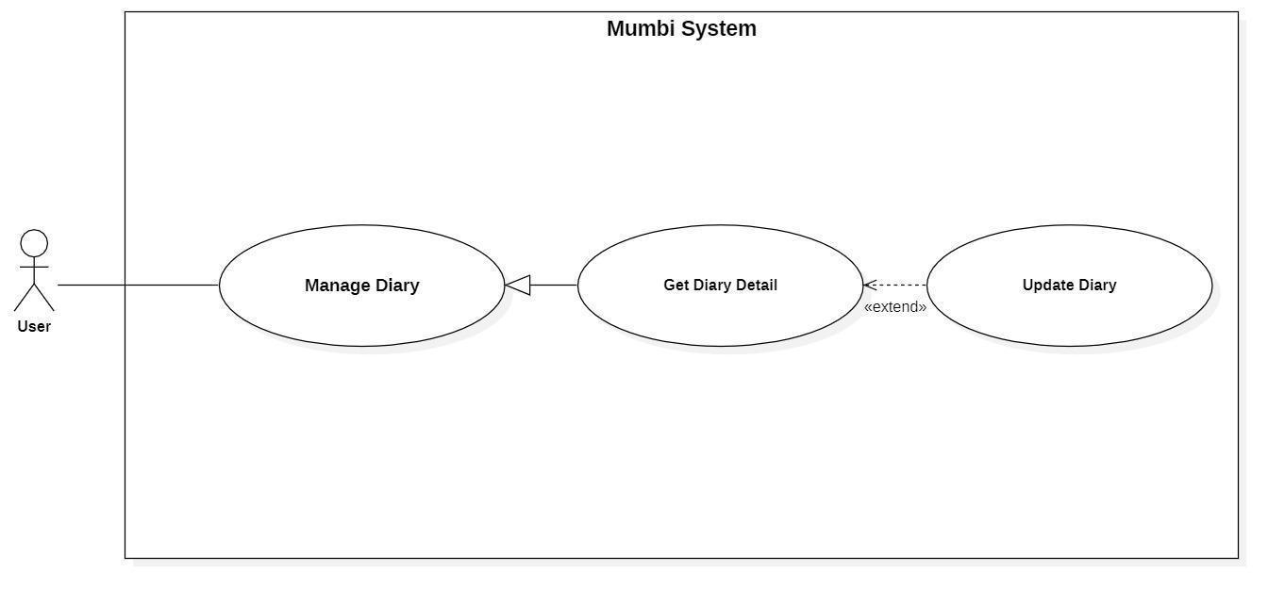

Figure 11 - <User> Update Diary

|  |  |  |  |
| --- | --- | --- | --- |
| **UC ID and Name:** | **Update Diary** | | |
| Created By: | Pham Hoang Duy | Date Created: | 19/05/2021 |
| Primary Actor: | User | Secondary Actors: | N/A |
| Trigger: | The actor indicates to update diary | | |
| Description: | Sometimes, users want to edit information in their diary. Therefore, this feature allows the actor to update the diary. | | |
| Preconditions: | The actor had been authorized as a user. | | |
| Post-conditions: | Success  The diary will be updated with new information.  Fail  The system shows an error message. | | |
| Normal Flow: | |  |  |  | | --- | --- | --- | | **Step** | **Actor Action** | **System Response** | | 1 | The actor sends a command to update the diary. | The system requests information of diary:   * Image * DiaryContent | | 2 | The actor updates the information in the diary.  The actor sent a request to update diary. | The system updates the diary with this information. | | | |
| Alternative Flows: | N/A | | |
| Exceptions: | N/A | | |
| Priority: | Medium | | |
| Frequency of Use: | Rarely | | |
| Business Rules: | − Mỗi nhật ký sẽ có thông tin riêng (ví dụ hình ảnh, nội dung) và các thông tin trên có thể thay đổi theo thời gian. Vì vậy, người dùng có thể cập nhật nó trên hệ thống.  − Thông tin của nhật ký sẽ bao gồm những thông tin sau:   * Hình ảnh * Nội dung   **\*English**  − Each diary will have its own information (for example image, content) and the above information may change over time. Therefore, the user can update it on the system.  − The diary information will include the following information:   * Image (Image) * Diary Content (DiaryContent) | | |
| Other Information: | N/A | | |
| Assumptions: | N/A | | |

Table 18 - <User> Update Diary

#### 2.3.8. Delete Diary

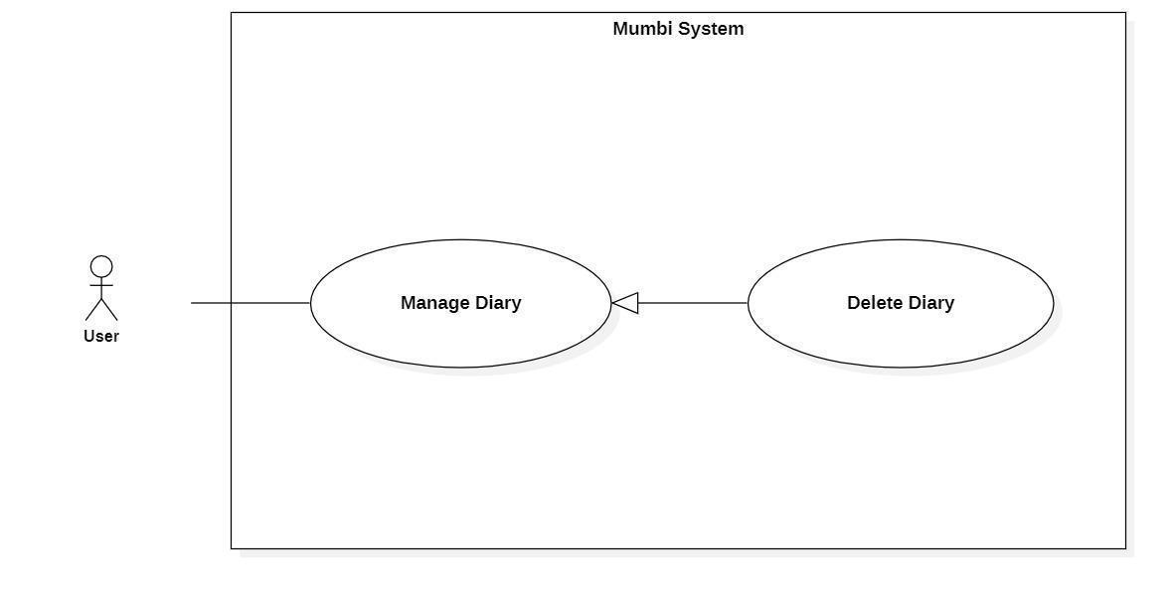

Figure 12 - <User> Delete Diary

|  |  |  |  |
| --- | --- | --- | --- |
| **UC ID and Name:** | **Delete Diary** | | |
| Created By: | Pham Hoang Duy | Date Created: | 20/05/2021 |
| Primary Actor: | User | Secondary Actors: | N/A |
| Trigger: | The actor sends a request to delete diary. | | |
| Description: | The actor needs to delete the diary from the system when it is no longer needed. Therefore, this feature allows the actor to delete the diary from the system. | | |
| Preconditions: | − The actor was authorized as a user. | | |
| Post-conditions: | Success  Send notification to the actor for deleting the diary and the selected diary will be hidden to the actor.  Fail  The system shows an error message. | | |
| Normal Flow: | |  |  |  | | --- | --- | --- | | **Step** | **Actor Action** | **System Response** | | 1 | The actor sends a command to delete the diary. | The system returns to the actor that the diary has been deleted. | | 2 | The actor sends a command to delete the diary. | The system changes the status of the diary. | | | |
| Alternative Flows: | N/A | | |
| Exceptions: | N/A | | |
| Priority: | Medium | | |
| Frequency of Use: | Rarely | | |
| Business Rules: | − Khi một nhật ký không còn cần thiết nữa, người dùng có thể xóa nhật ký đó ra khỏi hệ thống.  − Sau khi một nhật ký được xóa, nó sẽ được đổi trạng thái và người dùng không còn nhìn thấy nhật ký này.  **\*English**  − When a diary is no longer needed, the user can delete that diary from the system.  − After a diary is deleted, the status will be changed and the user should no longer see this diary. | | |
| Other Information: | N/A | | |
| Assumptions: | N/A | | |

Table 19 - <User> Delete Diary

#### 2.3.9. Get Children Detail

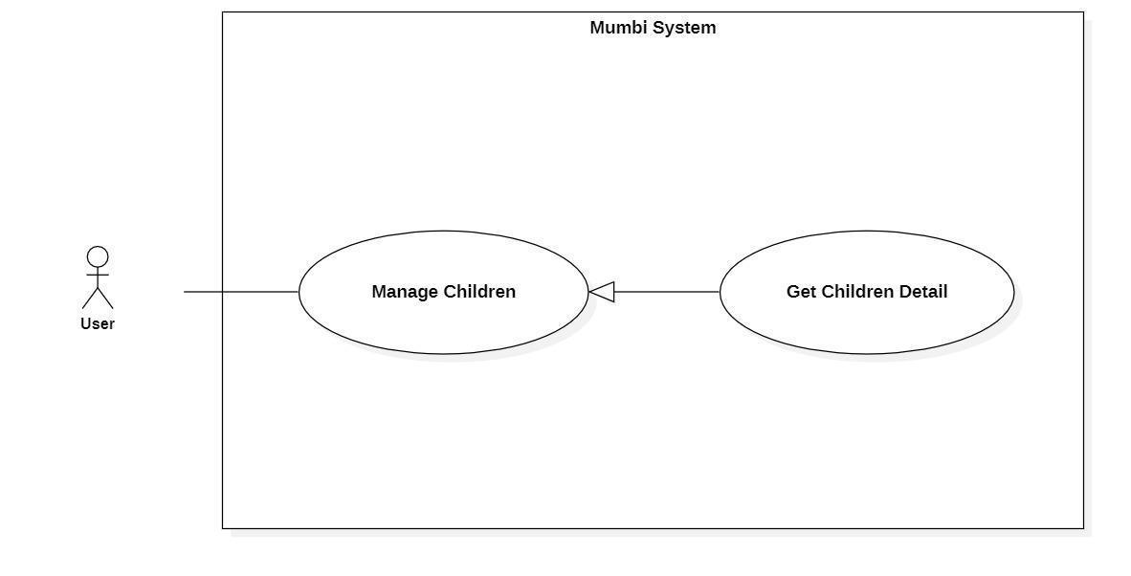

Figure 13 - <User> Get Children Detail

|  |  |  |  |
| --- | --- | --- | --- |
| **UC ID and Name:** | **Get Children Detail** | | |
| Created By: | Pham Hoang Duy | Date Created: | 20/05/2021 |
| Primary Actor: | User | Secondary Actors: | N/A |
| Trigger: | The actor wants to get details of children. | | |
| Description: | This feature allows the actor to get detailed information of a child's full name, nick name, image, gender, birthday, blood group, rh blood group, estimated born date, fingertips, head vortex... The user uses this information to make sure that every information is accurate. | | |
| Preconditions: | The actor had been authorized as a user. | | |
| Post-conditions: | Success  The actor receives details of children.  Fail  N/A | | |
| Normal Flow: | |  |  |  | | --- | --- | --- | | **Step** | **Actor Action** | **System Response** | | 1 | The actor wants to get details of children. | The system return detail of children includes:   * Fullname * Nickname * Image * Gender * Birthday * EstimatedBornDate * Bloodgroup * RhBloodGroup * Fingertips * HeadVortex | | | |
| Alternative Flows: | N/A | | |
| Exceptions: | N/A | | |
| Priority: | Medium | | |
| Frequency of Use: | Frequency | | |
| Business Rules: | - Hiển thị thông tin chi tiết của bé bao gồm:   * Họ và tên * Biệt danh * Hình ảnh * Giới tính * Ngày sinh * Ngày dự sinh * Nhóm máu * Hệ máu * Hoa tay * Xoáy đầu   **\* English**  − Display detail of children includes:   * Fullname * Nickname * Image * Gender * Birthday * EstimatedBornDate * Bloodgroup * RhBloodGroup * Fingertips * HeadVortex | | |
| Other Information: | N/A | | |
| Assumptions: | N/A | | |

Table 20 - <User> Get Children Detail

#### 2.3.10. Update Children Detail

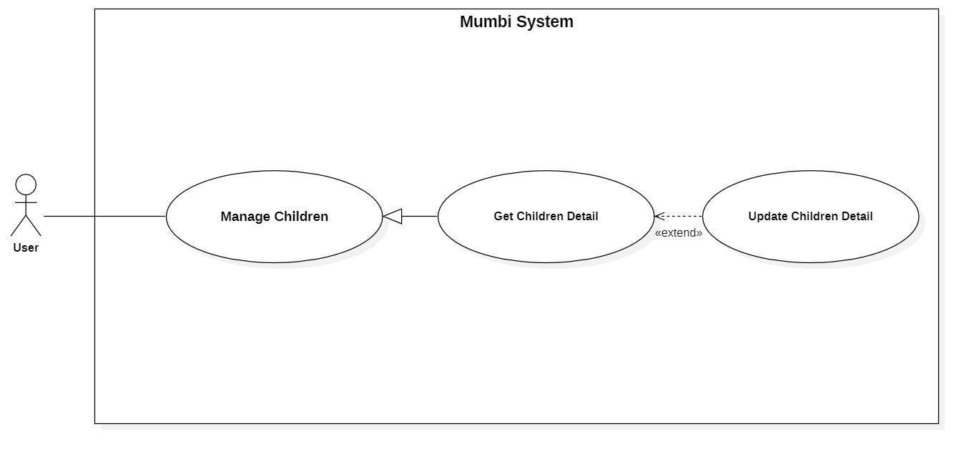

Figure 14 - <User> Update Children Detail

|  |  |  |  |
| --- | --- | --- | --- |
| **UC ID and Name:** | **Update Children Detail** | | |
| Created By: | Pham Hoang Duy | Date Created: | 19/05/2021 |
| Primary Actor: | User | Secondary Actors: | N/A |
| Trigger: | The actor indicates to update children's details. | | |
| Description: | Sometimes, users want to edit information in children's detail. Therefore, this feature allows the actor to update children's details. | | |
| Preconditions: | The actor had been authorized as a user. | | |
| Post-conditions: | Success  The children will be updated with new information.  Fail  The system shows an error message. | | |
| Normal Flow: | |  |  |  | | --- | --- | --- | | **Step** | **Actor Action** | **System Response** | | 1 | The actor sends a command to update children's details. | The system requests information of children:   * Fullname * Nickname * Image * Gender * Birthday * EstimatedBornDate * Bloodgroup * RhBloodGroup * Fingertips * HeadVortex | | 2 | The actor updates information about the children.  The actor sent a request to update the children 's details. | The system updates the children with this information. | | | |
| Alternative Flows: | N/A | | |
| Exceptions: | N/A | | |
| Priority: | Medium | | |
| Frequency of Use: | Rarely | | |
| Business Rules: | − Mỗi bé sẽ có thông tin riêng (ví dụ tên, hình ảnh, giới tính, nhóm máu, …) và các thông tin trên có thể thay đổi theo thời gian. Vì vậy, người dùng có thể cập nhật nó trên hệ thống.  − Thông tin của bé sẽ bao gồm những thông tin sau:   * Họ và tên (Fullname) * Biệt danh (Nickname) * Hình ảnh (Image) * Giới tính (Gender) * Ngày sinh (Birthday) * Ngày dự sinh (EstimatedBornDate) * Nhóm máu (BloodGroup) * Hệ máu (RhBloodGroup) * Hoa tay (Fingertips) * Xoáy đầu (HeadVortex)   **\*English**  − Each child will have its own information (for example fullname, image, gender, blood group, …) and the above information may change over time. Therefore, the user can update it on the system.  − The children information will include the following information:   * Fullname (Fullname) * Nickname (Nickname) * Image (Image) * Gender (Gender) * Birthday (Birthday) * EstimatedBornDate (EstimatedBornDate) * BloodGroup (BloodGroup) * RhBloodGroup (RhBloodGroup) * Fingertips (Fingertips) * HeadVortex (HeadVortex) | | |
| Other Information: | N/A | | |
| Assumptions: | N/A | | |

Table 21 - <User> Update Children Detail

#### 2.3.11. Delete Children

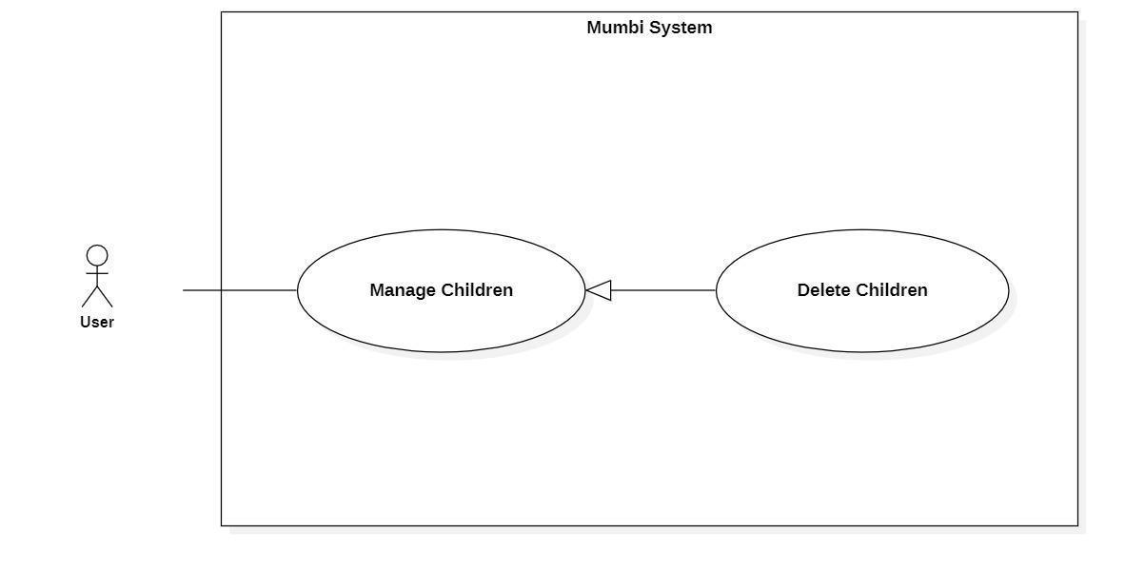

Figure 15 - <User> Delete Children

|  |  |  |  |
| --- | --- | --- | --- |
| **UC ID and Name:** | **Delete Children** | | |
| Created By: | Pham Hoang Duy | Date Created: | 20/05/2021 |
| Primary Actor: | User | Secondary Actors: | N/A |
| Trigger: | The actor sends a request to delete the children. | | |
| Description: | The actor needs to delete the children from the system when they make a mistake or when they unfortunately miscarry. Therefore, this feature allows the actor to delete the diary from the system. | | |
| Preconditions: | − The actor had been authorized as a user. | | |
| Post-conditions: | Success  Send notification to the actor for deleting children and the selected children will be hidden to the actor.  Fail  The system shows an error message. | | |
| Normal Flow: | |  |  |  | | --- | --- | --- | | **Step** | **Actor Action** | **System Response** | | 1 | The actor sends a command to delete the children. | The system returns to the actor that the children have been deleted. | | 2 | The actor sends a command to delete the children. | The system changes the status of the children. | | | |
| Alternative Flows: | N/A | | |
| Exceptions: | N/A | | |
| Priority: | Medium | | |
| Frequency of Use: | Rarely | | |
| Business Rules: | − Khi người dùng có sai sót khi lỡ thêm bé hoặc họ không may bị sẩy thai, người dùng có thể xóa bé.  − Sau khi một bé được xóa, bé sẽ được đổi trạng thái.  **\*English**  − When the user makes the mistake of adding a baby or they unfortunately miscarry, the user can delete the baby.  − After a child is deleted, the child will be changed status. | | |
| Other Information: | N/A | | |
| Assumptions: | N/A | | |

Table 22 - <User> Delete Children

#### 2.3.12. Follow Development Milestone

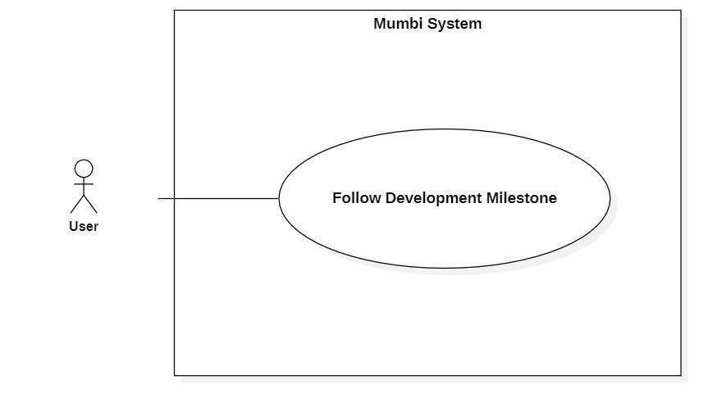

Figure 16 - <User> Follow Development Milestone

|  |  |  |  |
| --- | --- | --- | --- |
| **UC ID and Name:** | **Follow Development Milestone** | | |
| Created By: | Do Le Tu Uyen | Date Created: | 20/05/2021 |
| Primary Actor: | User | Secondary Actors: | N/A |
| Trigger: | The actor sends a request to follow development milestones. | | |
| Description: | The actor wants to monitor the development process so that we can offer solutions to help the baby develop in the best and most complete way. | | |
| Preconditions: | − The actor had been authorized as a user.  − The actor added children or pregnancy information. | | |
| Post-conditions: | Success  The actor receives information in the form of graphs and parameters for easy tracking and comparison of metrics.  Fail  The system shows an error message. | | |
| Normal Flow: | |  |  |  | | --- | --- | --- | | **Step** | **Actor Action** | **System Response** | | 1 | The actor sends a command to follow development milestones. | The system returns to the actor information in the form of graphs and parameter:   * Weight * Height * HeadCircumference * GrossMotorSkills * FineMotorSkills | | | |
| Alternative Flows: | N/A | | |
| Exceptions: | N/A | | |
| Priority: | Medium | | |
| Frequency of Use: | Rarely | | |
| Business Rules: | N/A | | |
| Other Information: | N/A | | |
| Assumptions: | N/A | | |

Table 23 - <User> Follow Development Milestone

#### 2.3.13. Create Family’s Profile

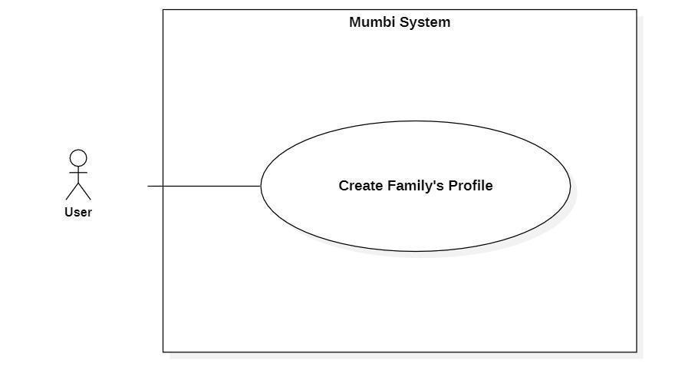

Figure 17 - <User> Create Family’s Profile

|  |  |  |  |
| --- | --- | --- | --- |
| **UC ID and Name:** | **Create Family’s Profile** | | |
| Created By: | Pham Hoang Duy | Date Created: | 20/05/2021 |
| Primary Actor: | User | Secondary Actors: | N/A |
| Trigger: | The actor sends a request to create a family’s profile. | | |
| Description: | The actor needs to have family’s profile to keep family information. Therefore, this feature allows the user to create family’s profile. | | |
| Preconditions: | The actor had been authorized as a user. | | |
| Post-conditions: | Success  A new family’s profile is created.  Fail  The system shows an error message. | | |
| Normal Flow: | |  |  |  | | --- | --- | --- | | **Step** | **Actor Action** | **System Response** | | 1 | The actor sends a command to create a family’s profile. | The system displays information of family’s profile to create:  If the profile is father or mother:   * Fullname * Image * Birthday * Phonenumber * BloodGroup * RhBloodGroup   If the profile is children:   * Fullname * Nickname * Image * Gender * Birthday * EstimatedBornDate * Bloodgroup * RhBloodGroup * Fingertips * HeadVortex | | 2 | The actor fills in information about the family’s profile. | The system receives information, create a new family’s profile. | | | |
| Alternative Flows: | N/A | | |
| Exceptions: | N/A | | |
| Priority: | Medium | | |
| Frequency of Use: | Frequently | | |
| Business Rules: | − Quy trình tạo hồ sơ:   * Điền các thông tin cơ bản của hồ sơ như hình ảnh, họ và tên, ngày sinh, nhóm máu, hệ máu. * Kiểm tra lại thông tin và gửi yêu cầu tạo một hồ sơ đến hệ thống.   − Hồ sơ bao gồm những trường cơ bản sau:   * Họ và tên * Hình ảnh * Ngày sinh * Nhóm máu * Hệ máu   **\*English**  − The process of creating a profile:   * Fill in and select the basic information of the profile such as image, fullname, birthday, blood group, rh blood group. * Check the information and send a request to create a profile to the system.   − Profile includes following fields:   * Fullname * Image * Birthday * BloodGroup * RhBloodGroup | | |
| Other Information: | N/A | | |
| Assumptions: | N/A | | |

Table 24 - <User> Create Family’s Profile

#### 2.3.14. Get Family’s Profile Detail

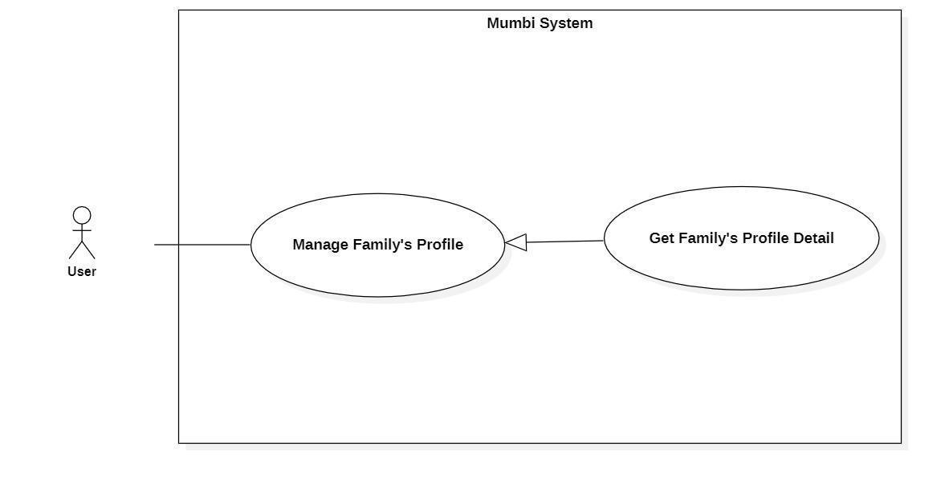

Figure 18 - <User> Get Family’s Profile

|  |  |  |  |
| --- | --- | --- | --- |
| **UC ID and Name:** | **Get Family’s Profile Detail** | | |
| Created By: | Pham Hoang Duy | Date Created: | 20/05/2021 |
| Primary Actor: | User | Secondary Actors: | N/A |
| Trigger: | The actor wants to get details of family’s profile. | | |
| Description: | This feature allows the actor to get detailed information of a profile including full name, nick name, image, gender, birthday, blood group, ... The user uses this information to make sure that every information is accurate. | | |
| Preconditions: | The actor had been authorized as a user. | | |
| Post-conditions: | Success  The actor receives details of children.  Fail  N/A | | |
| Normal Flow: | |  |  |  | | --- | --- | --- | | **Step** | **Actor Action** | **System Response** | | 1 | The actor wants to get details of profile. | The system return detail of profile includes:  If the profile is father or mother:   * Fullname * Image * Birthday * Phonenumber * BloodGroup * RhBloodGroup   If the profile is children:   * Fullname * Nickname * Image * Gender * Birthday * EstimatedBornDate * Bloodgroup * RhBloodGroup * Fingertips * HeadVortex | | | |
| Alternative Flows: | N/A | | |
| Exceptions: | N/A | | |
| Priority: | Medium | | |
| Frequency of Use: | Frequency | | |
| Business Rules: | - Hiển thị một số thông tin cơ bản của hồ sơ bao gồm:   * Họ và tên * Hình ảnh * Ngày sinh * Nhóm máu * Hệ máu   **\* English**  − Display some basic information of profile includes:   * Fullname * Image * Birthday * BloodGroup * RhBloodGroup | | |
| Other Information: | N/A | | |
| Assumptions: | N/A | | |

Table 25 - <User> Get Family’s Profile

#### 2.3.15. Update Family’s Profile

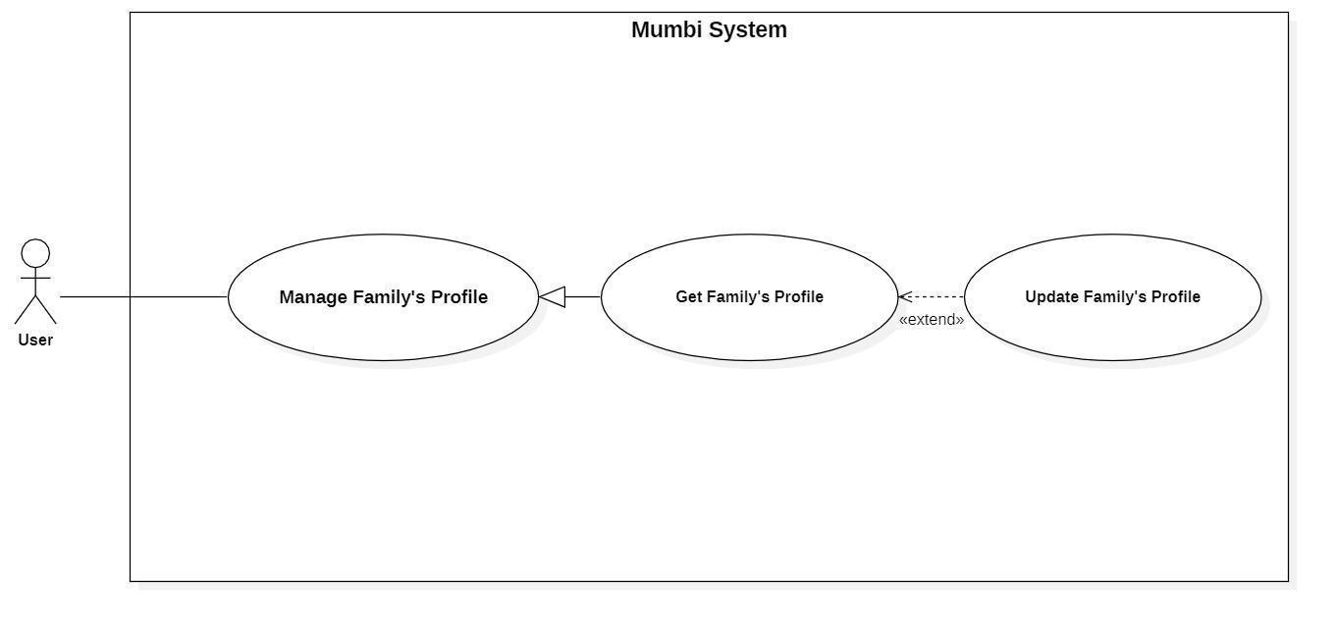

Figure 19 - <User> Update Family’s Profile

|  |  |  |  |
| --- | --- | --- | --- |
| **UC ID and Name:** | **Update Family’s Profile** | | |
| Created By: | Pham Hoang Duy | Date Created: | 19/05/2021 |
| Primary Actor: | User | Secondary Actors: | N/A |
| Trigger: | The actor indicates to update profile. | | |
| Description: | Sometimes, users want to edit information in their profile. Therefore, this feature allows the actor to update the profile. | | |
| Preconditions: | The actor had been authorized as a user. | | |
| Post-conditions: | Success  The profile will be updated with new information.  Fail  The system shows an error message. | | |
| Normal Flow: | |  |  |  | | --- | --- | --- | | **Step** | **Actor Action** | **System Response** | | 1 | The actor sends a command to update profile. | The system requests information of profile:  If the profile is father or mother:   * Fullname * Image * Birthday * Phonenumber * BloodGroup * RhBloodGroup   If the profile is children:   * Fullname * Nickname * Image * Gender * Birthday * EstimatedBornDate * Bloodgroup * RhBloodGroup * Fingertips * HeadVortex | | 2 | The actor updates the profile.  The actor sent a request to update profile. | The system updates the profile with this information. | | | |
| Alternative Flows: | N/A | | |
| Exceptions: | N/A | | |
| Priority: | Medium | | |
| Frequency of Use: | Rarely | | |
| Business Rules: | − Mỗi hồ sơ sẽ có thông tin riêng và các thông tin trên có thể thay đổi theo thời gian. Vì vậy, người dùng có thể cập nhật nó trên hệ thống.  − Thông tin của hồ sơ sẽ bao gồm những thông tin cơ bản sau:   * Fullname * Image * Birthday * BloodGroup * RhBloodGroup   **\*English**  − Each profile will have its own information and the above information may change over time. Therefore, the user can update it on the system.  − The profile information will include the following basic information:   * Fullname (Fullname) * Image (Image) * Birthday (Birthday) * BloodGroup (BloodGroup) * RhBloodGroup (RhBloodGroup) | | |
| Other Information: | N/A | | |
| Assumptions: | N/A | | |

Table 26 - <User> Update Family’s Profile

#### 2.3.16. Delete Family’s Profile

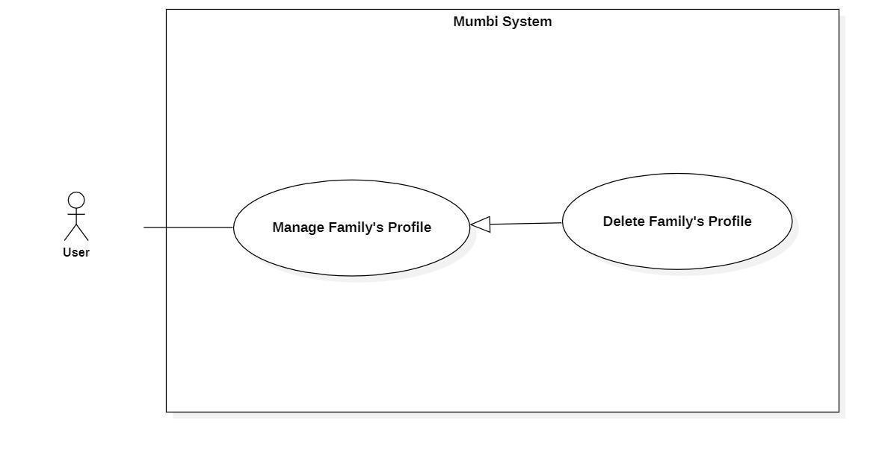

Figure 20 - <User> Delete Family’s Profile

|  |  |  |  |
| --- | --- | --- | --- |
| **UC ID and Name:** | **Delete Family’s Profile** | | |
| Created By: | Pham Hoang Duy | Date Created: | 20/05/2021 |
| Primary Actor: | User | Secondary Actors: | N/A |
| Trigger: | The actor sends a request to delete profile. | | |
| Description: | The actor needs to delete the profile from the system when it is no longer needed. Therefore, this feature allows the actor to delete the profile from the system. | | |
| Preconditions: | − The actor had been authorized as a user. | | |
| Post-conditions: | Success  Send notification to the actor for deleting the profile and the selected profile will be hidden to the actor.  Fail  The system shows an error message. | | |
| Normal Flow: | |  |  |  | | --- | --- | --- | | **Step** | **Actor Action** | **System Response** | | 1 | The actor sends a command to delete the profile. | The system returns to the actor whose profile has been deleted. | | 2 | The actor sends a command to delete the profile. | The system changes the status of the profile. | | | |
| Alternative Flows: | N/A | | |
| Exceptions: | N/A | | |
| Priority: | Medium | | |
| Frequency of Use: | Rarely | | |
| Business Rules: | − Khi một hồ sơ không còn cần thiết nữa, người dùng có thể xóa hồ sơ đó ra khỏi hệ thống.  − Sau khi một hồ sơ được xóa, nó sẽ được đổi trạng thái và người dùng không còn nhìn thấy nhật ký này.  **\*English**  − When a profile is no longer needed, the user can delete that profile from the system.  − After a diary is deleted, the status will be changed and the user should no longer see this profile. | | |
| Other Information: | N/A | | |
| Assumptions: | N/A | | |

Table 27 - <User> Delete Family’s Profile

### 2.4 Staff

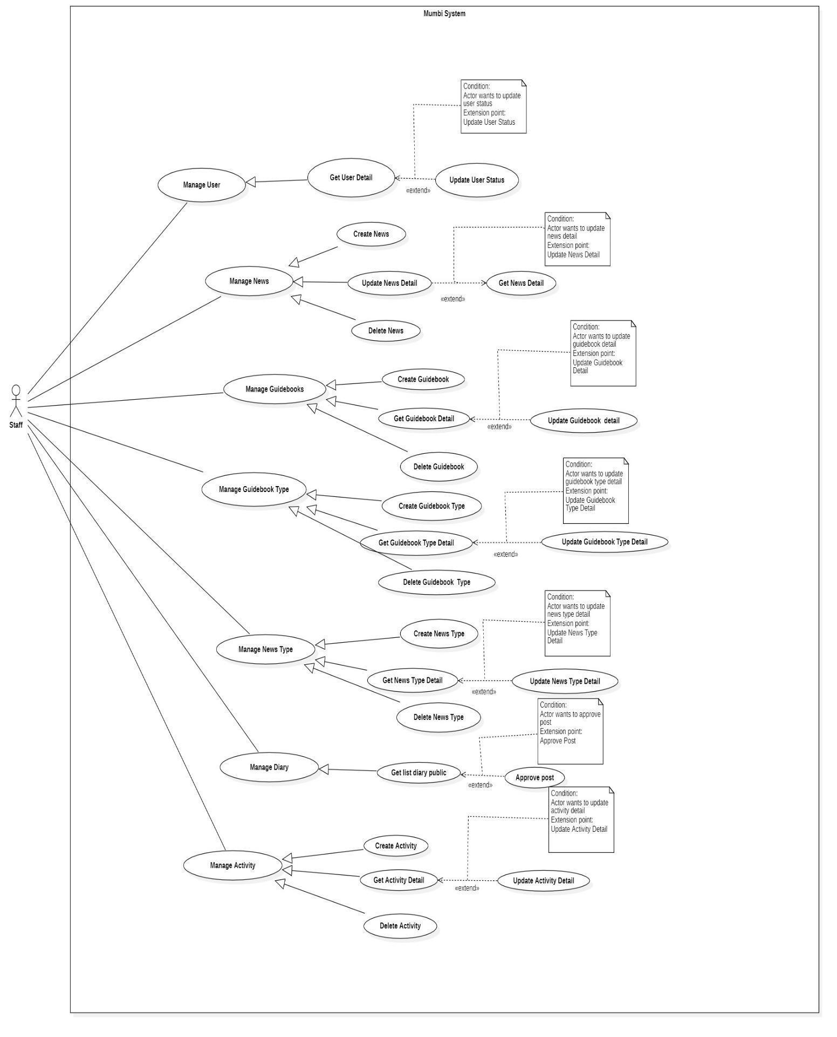

Figure 21 - <Staff> Overview Use Case Diagram

#### 2.4.1. Create News

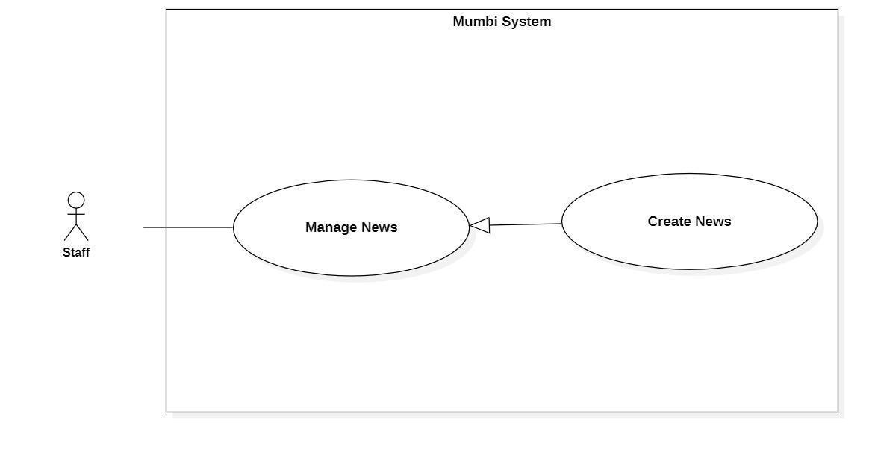

Figure 22 - <Staff> Create News

|  |  |  |  |
| --- | --- | --- | --- |
| **UC ID and Name:** | **Create News** | | |
| Created By: | Than Quoc Binh | Date Created: | 20/05/2021 |
| Primary Actor: | Staff | Secondary Actors: | N/A |
| Trigger: | The actor sends a request to create a news. | | |
| Description: | The actor needs to have news to help the user have the necessary knowledge. Therefore, this feature allows the actor to create news. | | |
| Preconditions: | The actor had been authorized as a user. | | |
| Post-conditions: | Success  New news is created.  Fail  The system shows an error message. | | |
| Normal Flow: | |  |  |  | | --- | --- | --- | | **Step** | **Actor Action** | **System Response** | | 1 | The actor sends a command to create a news. | The system displays information of news to create:   * Image * NewsContent * Title * Type * EstimatedFinishTime | | 2 | The actor fills in information about the news. | The system receives information, create a new news. | | | |
| Alternative Flows: | N/A | | |
| Exceptions: | N/A | | |
| Priority: | Medium | | |
| Frequency of Use: | Frequently | | |
| Business Rules: | − Các tin tức sẽ giúp người dùng có những thông tin mới nhất cũng như giúp người dùng có thêm nhiều góc nhìn khách quan hơn trong việc chăm sóc và nuôi dạy bé.  − Quy trình tạo tin tức:   * Điền và lựa chọn các thông tin cơ bản của tin tức như hình ảnh, nội dung tin tức, tiêu đề, loại tin tức, thời gian dự kiến để đọc. * Kiểm tra lại thông tin và gửi yêu cầu tạo một tin tức mới đến hệ thống.   − Tin tức bao gồm những trường sau:   * Hình ảnh * Nội dung tin tức * Tiêu đề * Loại tin tức * Thời gian dự kiến để đọc   **\*English**  - The news will help users have the latest information as well as help users have more objective perspectives in caring and raising babies.  − The process of creating a news:   * Fill in and select the basic information of the news such as news content, image, title, type, estimated finish time. * Check the information and send a request to create new news to the system.   − News includes following fields:   * Image * NewsContent * Title * Type * EstimatedFinishTime | | |
| Other Information: | N/A | | |
| Assumptions: | N/A | | |

Table 28 - <User> Create News

#### 2.4.2. Get News Detail

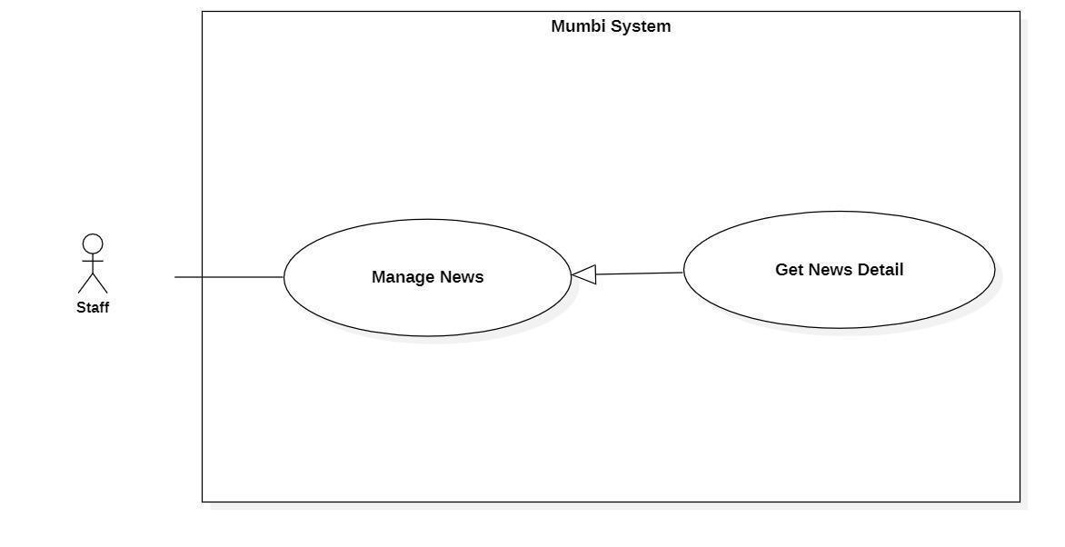

Figure 23 - <Staff> Get News Detail

|  |  |  |  |
| --- | --- | --- | --- |
| **UC ID and Name:** | **Get News Detail** | | |
| Created By: | Than Quoc Binh | Date Created: | 20/05/2021 |
| Primary Actor: | Staff | Secondary Actors: | N/A |
| Trigger: | The actor wants to get details of the news. | | |
| Description: | This feature allows the actor to get detailed information about news including news content, image, title, type… The user uses this information to make sure that every information is exactly. | | |
| Preconditions: | The actor had been authorized as a user. | | |
| Post-conditions: | Success  The actor receives details of the news.  Fail  N/A | | |
| Normal Flow: | |  |  |  | | --- | --- | --- | | **Step** | **Actor Action** | **System Response** | | 1 | The actor wants to get details of the news. | The system return detail of news includes:   * Image * NewsContent * Title * Type * EstimatedFinishTime | | | |
| Alternative Flows: | N/A | | |
| Exceptions: | N/A | | |
| Priority: | Medium | | |
| Frequency of Use: | Frequency | | |
| Business Rules: | - Hiển thị thông tin chi tiết của tin tức bao gồm:   * Hình ảnh * Nội dung tin tức * Tiêu đề * Loại tin tức * Thời gian dự kiến để đọc   * English  − Display detail of news includes:   * Image * NewsContent * Title * Type * EstimatedFinishTime | | |
| Other Information: | N/A | | |
| Assumptions: | N/A | | |

Table 29 - <Staff> Get News Detail

#### 2.4.3. Update News Detail

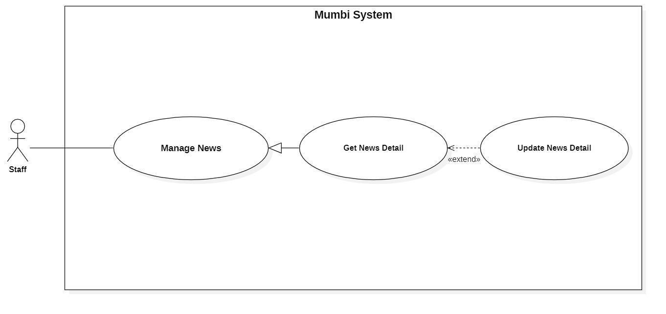

Figure 24 - <Staff> Update News Detail

|  |  |  |  |
| --- | --- | --- | --- |
| **UC ID and Name:** | **Update News Detail** | | |
| Created By: | Than Quoc Binh | Date Created: | 19/05/2021 |
| Primary Actor: | Staff | Secondary Actors: | N/A |
| Trigger: | The actor indicates to update news | | |
| Description: | Sometimes, users want to edit information in the news. Therefore, this feature allows the actor to update the news. | | |
| Preconditions: | The actor had been authorized as a user. | | |
| Post-conditions: | Success  The news will be updated with new information.  Fail  The system shows an error message. | | |
| Normal Flow: | |  |  |  | | --- | --- | --- | | **Step** | **Actor Action** | **System Response** | | 1 | The actor sends a command to update the news. | The system requests information of news:   * Image * NewsContent * Title * Type * EstimatedFinishTime | | 2 | The actor updates the news.  The actor sent a request to update the news. | The system updates the news with this information. | | | |
| Alternative Flows: | N/A | | |
| Exceptions: | N/A | | |
| Priority: | Medium | | |
| Frequency of Use: | Rarely | | |
| Business Rules: | − Mỗi tin tức sẽ có thông tin riêng và các thông tin trên có thể thay đổi theo thời gian. Vì vậy, nhân viên có thể cập nhật nó trên hệ thống.  − Thông tin của nhật ký sẽ bao gồm những thông tin sau:   * Hình ảnh (Image) * Nội dung tin tức (NewsContent) * Tiêu đề (Title) * Loại tin tức (Type) * Thời gian dự kiến để đọc (EstimatedFinishTime)   **\*English**  − Each news article will have its own information and the above information may change over time. Therefore, the staff can update it on the system.  − The news information will include the following information:   * Image (Image) * NewsContent (NewsContent) * Title (Title) * Type (Type) * EstimatedFinishTime (EstimatedFinishTime) | | |
| Other Information: | N/A | | |
| Assumptions: | N/A | | |

Table 30 - <User> Update News Detail

#### 2.4.4. Delete News

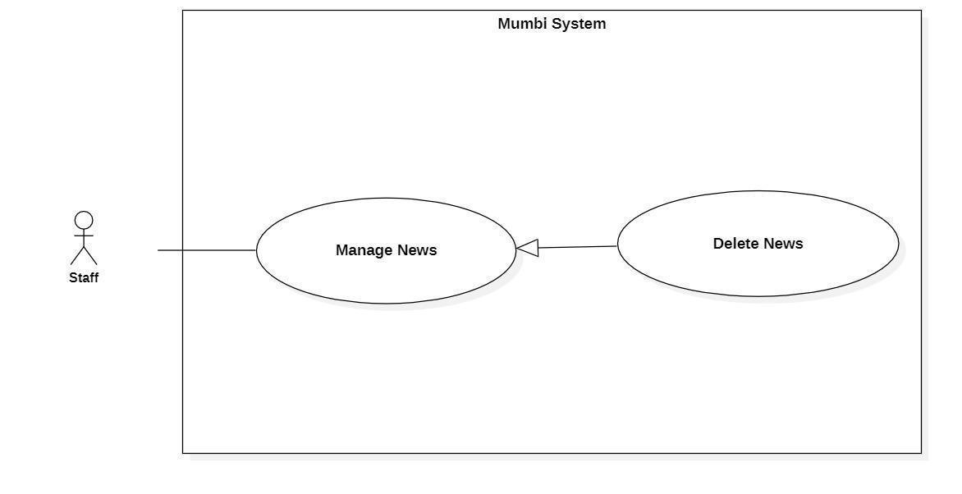

Figure 25 - <Staff> Delete News

|  |  |  |  |
| --- | --- | --- | --- |
| **UC ID and Name:** | **Delete News** | | |
| Created By: | Than Quoc Binh | Date Created: | 20/05/2021 |
| Primary Actor: | Staff | Secondary Actors: | N/A |
| Trigger: | The actor sends a request to delete the news. | | |
| Description: | The actor needs to delete the news from the system when it is no longer needed. Therefore, this feature allows the actor to delete the news from the system. | | |
| Preconditions: | − The actor had been authorized as a staff. | | |
| Post-conditions: | Success  Send notification to the actor for deleting news and the selected news will be hidden to the actor.  Fail  The system shows an error message. | | |
| Normal Flow: | |  |  |  | | --- | --- | --- | | **Step** | **Actor Action** | **System Response** | | 1 | The actor sends a command to delete the news. | The system returns to the actor that the news has been deleted. | | 2 | The actor sends a command to delete the news. | The system changes the status of the news. | | | |
| Alternative Flows: | N/A | | |
| Exceptions: | N/A | | |
| Priority: | Medium | | |
| Frequency of Use: | Rarely | | |
| Business Rules: | − Khi một tin tức không còn cần thiết nữa, nhân viên có thể xóa tin tức đó ra khỏi hệ thống.  − Sau khi một tin tức được xóa, nó sẽ được đổi trạng thái và nhân viên không còn nhìn thấy tin tức này.  **\*English**  − When news is no longer needed, the staff can delete that news from the system.  − After the news is deleted, the status will be changed and the staff should no longer see this news. | | |
| Other Information: | N/A | | |
| Assumptions: | N/A | | |

Table 31 - <Staff> Delete News

#### 2.4.5. Create Guidebooks

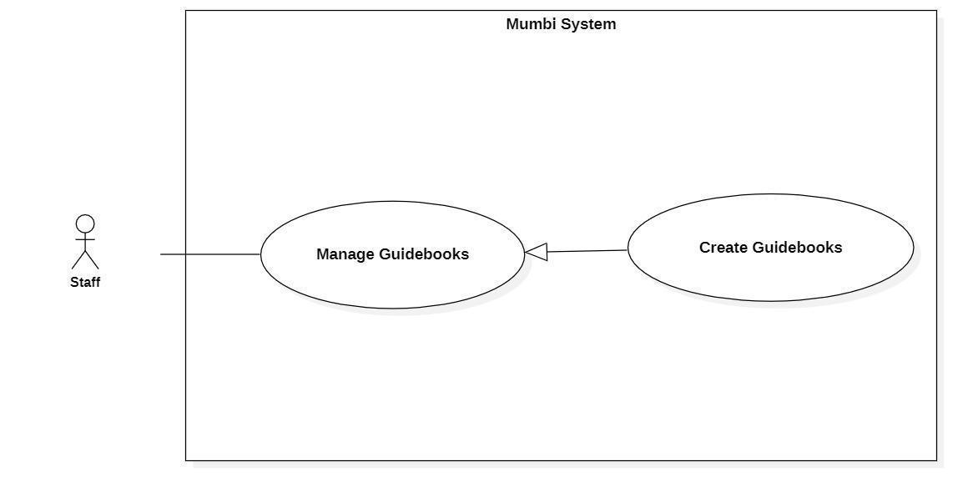

Figure 26 - <Staff> Create Guidebooks

|  |  |  |  |
| --- | --- | --- | --- |
| **UC ID and Name:** | **Create Guidebooks** | | |
| Created By: | Than Quoc Binh | Date Created: | 20/05/2021 |
| Primary Actor: | Staff | Secondary Actors: | N/A |
| Trigger: | The actor sends a request to create a guidebook. | | |
| Description: | The actor needs to have a guidebook to provide users with useful information. Therefore, this feature allows the staff to create guidebooks. | | |
| Preconditions: | The actor had been authorized as a staff. | | |
| Post-conditions: | Success  A new guidebook is created.  Fail  The system shows an error message. | | |
| Normal Flow: | |  |  |  | | --- | --- | --- | | **Step** | **Actor Action** | **System Response** | | 1 | The actor sends a command to create a guidebook. | The system displays information of guidebook to create:   * GuidebookContent * Image * Title * Type * EstimatedFinishTime | | 2 | The actor fills in information about the guidebook. | The system receives information, create a new guidebook. | | | |
| Alternative Flows: | N/A | | |
| Exceptions: | N/A | | |
| Priority: | Medium | | |
| Frequency of Use: | Frequently | | |
| Business Rules: | − Các cẩm nang sẽ hướng dẫn người dùng có thể chăm sóc và nuôi dạy bé một cách tốt nhất.  − Quy trình tạo cẩm nang:   * Điền và lựa chọn các thông tin cơ bản của cẩm nang như hình ảnh, nội dung cẩm nang, tiêu đề, loại cẩm nang, thời gian dự kiến để đọc. * Kiểm tra lại thông tin và gửi yêu cầu tạo một cẩm nang mới đến hệ thống.   − Tin tức bao gồm những trường sau:   * Hình ảnh * Nội dung cẩm nang * Tiêu đề * Loại cẩm nang * Thời gian dự kiến để đọc   **\*English**  - The guidebook will guide the user to take care and raise the baby in the best way.  − The process of creating a guidebook:   * Fill in and select the basic information of the guidebook such as guidebook content, image, title, type, estimated finish time. * Check the information and send a request to create a new guidebook to the system.   − Guidebook includes following fields:   * Image * GuidebookContent * Title * Type * EstimatedFinishTime | | |
| Other Information: | N/A | | |
| Assumptions: | N/A | | |

Table 32 - <Staff> Create Guidebooks

#### 2.4.6. Get Guidebooks Detail

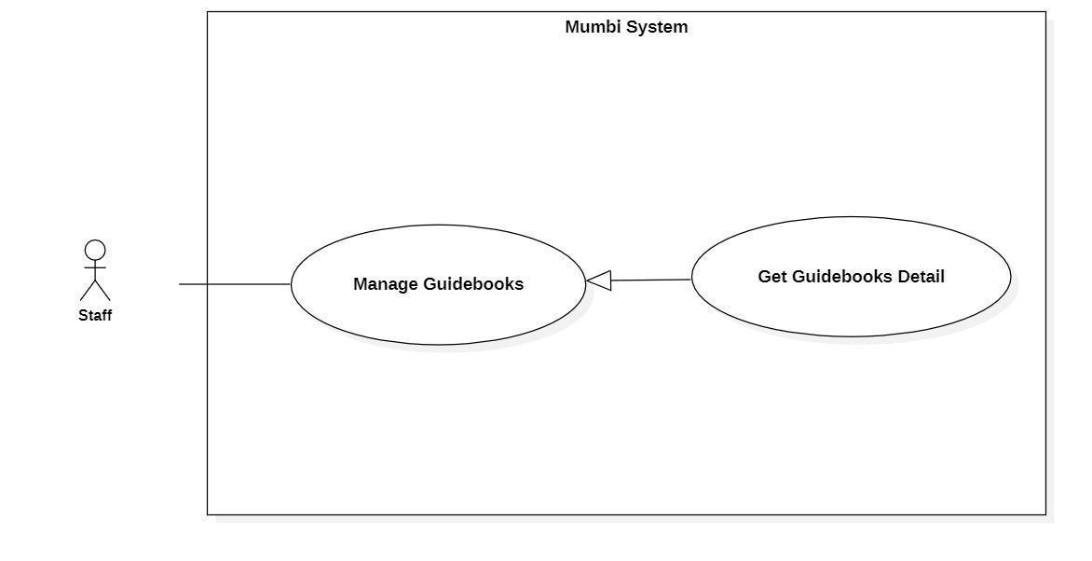

Figure 27 - <Staff> Get Guidebooks Detail

|  |  |  |  |
| --- | --- | --- | --- |
| **UC ID and Name:** | **Get Guidebooks Detail** | | |
| Created By: | Than Quoc Binh | Date Created: | 20/05/2021 |
| Primary Actor: | Staff | Secondary Actors: | N/A |
| Trigger: | The actor wants to get the details of the guidebook. | | |
| Description: | This feature allows the actor to get detailed information of a guidebook including guidebook content, image, title, type. The staff uses this information to make sure that every information is accurate. | | |
| Preconditions: | The actor had been authorized as a staff. | | |
| Post-conditions: | Success  The actor receives details from the guidebook.  Fail  N/A | | |
| Normal Flow: | |  |  |  | | --- | --- | --- | | **Step** | **Actor Action** | **System Response** | | 1 | The actor wants to get the details of the guidebook. | The system return detail of guidebook includes:   * GuidebookContent * Image * Title * Type * EstimatedFinishTime | | | |
| Alternative Flows: | N/A | | |
| Exceptions: | N/A | | |
| Priority: | Medium | | |
| Frequency of Use: | Frequency | | |
| Business Rules: | - Hiển thị thông tin chi tiết của cẩm nang bao gồm:   * Hình ảnh * Nội dung cẩm nang * Tiêu đề * Loại tin tức * Thời gian dự kiến để đọc   * English  − Display detail of guidebook includes:   * Image * GuidebookContent * Title * Type * EstimatedFinishTime | | |
| Other Information: | N/A | | |
| Assumptions: | N/A | | |

Table 33 - <Staff> Get Guidebooks Detail

#### 2.4.7. Update Guidebooks Detail

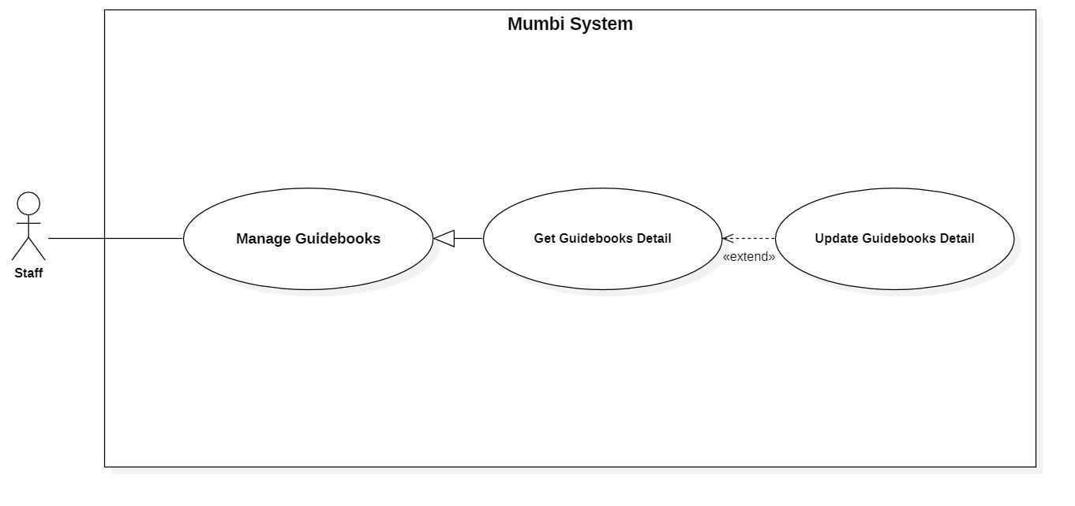

Figure 28 - <Staff> Update Guidebooks Detail

|  |  |  |  |
| --- | --- | --- | --- |
| **UC ID and Name:** | **Update Guidebooks Detail** | | |
| Created By: | Than Quoc Binh | Date Created: | 19/05/2021 |
| Primary Actor: | Staff | Secondary Actors: | N/A |
| Trigger: | The actor indicates to update guidebooks | | |
| Description: | Sometimes, users want to edit information in a guidebook. Therefore, this feature allows the actor to update the guidebook detail. | | |
| Preconditions: | The actor had been authorized as a staff. | | |
| Post-conditions: | Success  The guidebook will be updated with new information.  Fail  The system shows an error message. | | |
| Normal Flow: | |  |  |  | | --- | --- | --- | | **Step** | **Actor Action** | **System Response** | | 1 | The actor sends a command to update the guidebook. | The system requests information of guidebook:   * Title * GuidebookContent * Image * Type * EstimatedFinishTime | | 2 | The actor updates the information in the guidebook.  The actor sent a request to update the guidebook. | The system updates the guidebook with this information. | | | |
| Alternative Flows: | N/A | | |
| Exceptions: | N/A | | |
| Priority: | Medium | | |
| Frequency of Use: | Rarely | | |
| Business Rules: | − Mỗi cẩm nang sẽ có thông tin riêng (ví dụ hình ảnh, nội dung, tiêu đề, loại cẩm nang) và các thông tin trên có thể thay đổi theo thời gian. Vì vậy, nhân viên có thể cập nhật nó trên hệ thống.  − Thông tin của cẩm nang sẽ bao gồm những thông tin sau:   * Hình ảnh (Image) * Tiêu đề (Title) * Nội dung (GuidebookContent) * Loại cẩm nang (Type) * Ước lượng thời gian (EstimatedFinishTime):   **\*English**  − Each guidebook will have its own information (for example image, content) and the above information may change over time. Therefore, the staff can update it on the system.  − The guidebook information will include the following information:   * Image (Image) * Title (Title) * Guidebook Content (GuidebookContent) * Type (Type) * EstimatedFinishTime (EstimatedFinishTime): | | |
| Other Information: | N/A | | |
| Assumptions: | N/A | | |

Table 34 - <Staff> Update Guidebooks Detail

#### 2.4.8. Delete Guidebooks

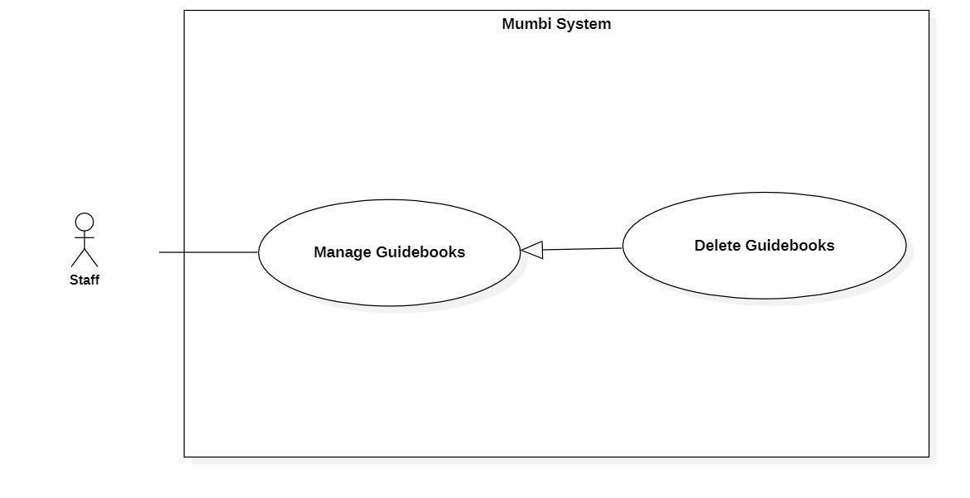

Figure 29 - <Staff> Delete Guidebooks

|  |  |  |  |
| --- | --- | --- | --- |
| **UC ID and Name:** | **Delete Guidebooks** | | |
| Created By: | Than Quoc Binh | Date Created: | 20/05/2021 |
| Primary Actor: | Staff | Secondary Actors: | N/A |
| Trigger: | The actor sends a request to delete the guidebook. | | |
| Description: | The actor needs to delete the guidebook from the system when it is no longer needed. Therefore, this feature allows the actor to delete the guidebook from the system. | | |
| Preconditions: | − The actor had been authorized as a staff. | | |
| Post-conditions: | Success  Send notification to the actor for deleting the guidebook and the selected guidebook will be hidden to the actor.  Fail  The system shows an error message. | | |
| Normal Flow: | |  |  |  | | --- | --- | --- | | **Step** | **Actor Action** | **System Response** | | 1 | The actor sends a command to delete the guidebook. | The system returns to the actor that the guidebook has been deleted. | | 2 | The actor sends a command to delete the guidebook. | The system changes the status of the guidebook. | | | |
| Alternative Flows: | N/A | | |
| Exceptions: | N/A | | |
| Priority: | Medium | | |
| Frequency of Use: | Rarely | | |
| Business Rules: | − Khi một cẩm nang không còn cần thiết nữa, nhân viên có thể xóa nhật ký đó ra khỏi hệ thống.  − Sau khi một cẩm nang được xóa, nó sẽ được đổi trạng thái và nhân viên không còn nhìn thấy cẩm nang này.  **\*English**  − When a guidebook is no longer needed, the staff can delete that guidebook from the system.  − After a guidebook is deleted, the status will be changed and the staff should no longer see this diary. | | |
| Other Information: | N/A | | |
| Assumptions: | N/A | | |

Table 35 - <Staff> Delete Guidebooks

#### 2.4.9. Create Guidebooks Type

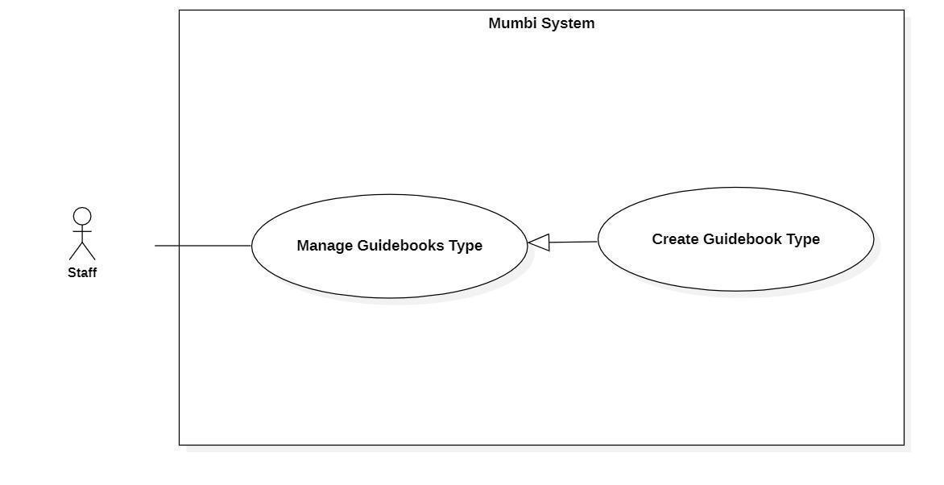

Figure 30 - <Staff> Create Guidebooks Type

|  |  |  |  |
| --- | --- | --- | --- |
| **UC ID and Name:** | **Create Guidebooks Type** | | |
| Created By: | Than Quoc Binh | Date Created: | 20/05/2021 |
| Primary Actor: | User | Secondary Actors: | N/A |
| Trigger: | The actor sends a request to create a guidebook type. | | |
| Description: | The actor needs to have a guidebook type to classify the guidebook. Therefore, this feature allows the staff to create guidebook types. | | |
| Preconditions: | The actor had been authorized as a staff. | | |
| Post-conditions: | Success  A new guidebook type is created.  Fail  The system shows an error message. | | |
| Normal Flow: | |  |  |  | | --- | --- | --- | | **Step** | **Actor Action** | **System Response** | | 1 | The actor sends a command to create a guidebook type. | The system displays information of guidebook type to create:   * Type | | 2 | The actor fills in information about the guidebook type. | The system receives information, create a new guidebook type. | | | |
| Alternative Flows: | N/A | | |
| Exceptions: | N/A | | |
| Priority: | Medium | | |
| Frequency of Use: | Frequently | | |
| Business Rules: | − Quy trình tạo loại cẩm nang:   * Điền thông tin cơ bản của loại cẩm nang. * Kiểm tra lại thông tin và gửi yêu cầu tạo một loại cẩm nang mới đến hệ thống.   − Loại cẩm nang bao gồm những trường sau:   * Loại cẩm nang   **\*English**  − The process of creating a guidebook type:   * Fill in and select the basic information of the guidebook type. * Check the information and send a request to create a new guidebook type to the system.   − Guidebook type includes following fields:   * Type | | |
| Other Information: | N/A | | |
| Assumptions: | N/A | | |

Table 36 - <Staff> Create Guidebooks Type

#### 2.4.10. Get Guidebooks Type Detail

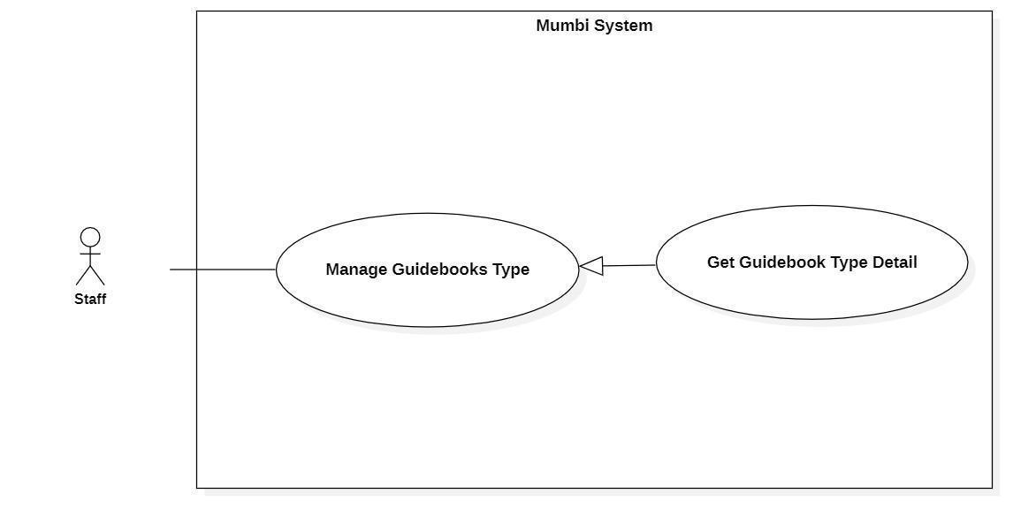

Figure 31 - <Staff> Get Guidebooks Type Detail

|  |  |  |  |
| --- | --- | --- | --- |
| **UC ID and Name:** | **Get Guidebooks Type Detail** | | |
| Created By: | Than Quoc Binh | Date Created: | 20/05/2021 |
| Primary Actor: | Staff | Secondary Actors: | N/A |
| Trigger: | The actor wants to get details of the guidebook type. | | |
| Description: | This feature allows the actor to get detailed information of a guidebook type. The staff uses this information to make sure that every information is accurate. | | |
| Preconditions: | The actor had been authorized as a staff. | | |
| Post-conditions: | Success  The actor receives details from the guidebook.  Fail  N/A | | |
| Normal Flow: | |  |  |  | | --- | --- | --- | | **Step** | **Actor Action** | **System Response** | | 1 | The actor wants to get details of the guidebook type. | The system return detail of guidebook type includes:   * Type | | | |
| Alternative Flows: | N/A | | |
| Exceptions: | N/A | | |
| Priority: | Medium | | |
| Frequency of Use: | Frequency | | |
| Business Rules: | - Hiển thị thông tin chi tiết của loại cẩm nang bao gồm:   * Loại cẩm nang   * English  − Display detail of guidebook type includes:   * Type | | |
| Other Information: | N/A | | |
| Assumptions: | N/A | | |

Table 37 - <Staff> Get Guidebooks Type Detail

#### 2.4.11. Update Guidebooks Type Detail

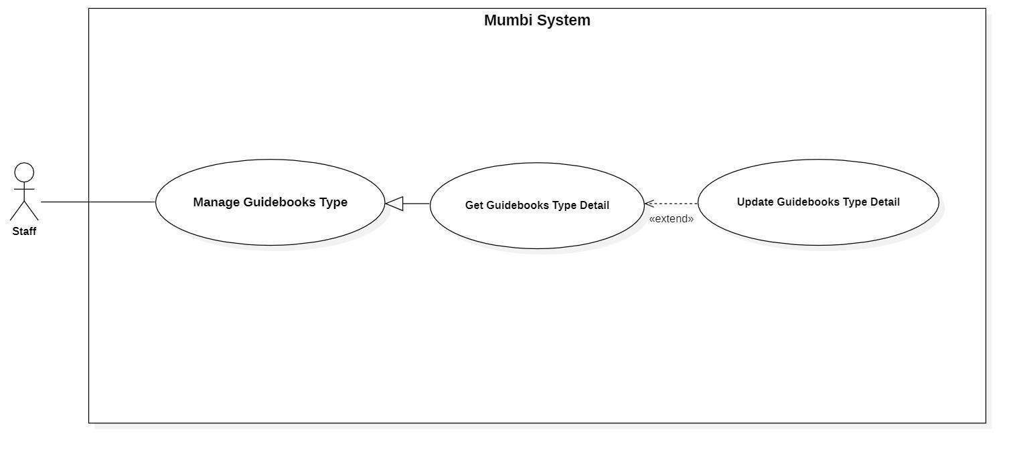

Figure 32 - <Staff> Update Guidebooks Type Detail

|  |  |  |  |
| --- | --- | --- | --- |
| **UC ID and Name:** | **Update Guidebooks Detail** | | |
| Created By: | Than Quoc Binh | Date Created: | 19/05/2021 |
| Primary Actor: | Staff | Secondary Actors: | N/A |
| Trigger: | The actor indicates to update guidebooks | | |
| Description: | Sometimes, users want to edit information in guidebook type. Therefore, this feature allows the actor to update the guidebook type detail. | | |
| Preconditions: | The actor had been authorized as a staff. | | |
| Post-conditions: | Success  The guidebook type will be updated with new information.  Fail  The system shows an error message. | | |
| Normal Flow: | |  |  |  | | --- | --- | --- | | **Step** | **Actor Action** | **System Response** | | 1 | The actor sends a command to update the guidebook type. | The system requests information of guidebook:   * Type | | 2 | The actor updates information of the guidebook type.  The actor sends a request to update the guidebook type. | The system updates the guidebook type with this information. | | | |
| Alternative Flows: | N/A | | |
| Exceptions: | N/A | | |
| Priority: | Medium | | |
| Frequency of Use: | Rarely | | |
| Business Rules: | − Mỗi loại cẩm nang sẽ có thông tin riêng và các thông tin trên có thể thay đổi theo thời gian. Vì vậy, nhân viên có thể cập nhật nó trên hệ thống.  − Thông tin của cẩm nang sẽ bao gồm những thông tin sau:   * Loại cẩm nang (Type):   **\*English**  − Each guidebook type will have its own information and the above information may change over time. Therefore, the staff can update it on the system.  − The guidebook type information will include the following information:   * Type (Type): | | |
| Other Information: | N/A | | |
| Assumptions: | N/A | | |

Table 38 - <Staff> Update Guidebooks Type Detail

#### 2.4.12. Delete Guidebooks Type

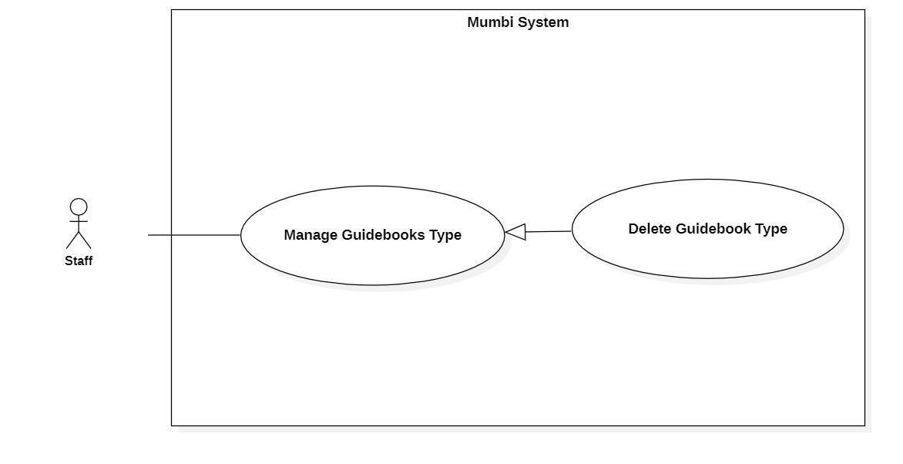

Figure 33 - <Staff> Delete Guidebooks Type

|  |  |  |  |
| --- | --- | --- | --- |
| **UC ID and Name:** | **Delete Guidebooks Type** | | |
| Created By: | Than Quoc Binh | Date Created: | 20/05/2021 |
| Primary Actor: | Staff | Secondary Actors: | N/A |
| Trigger: | The actor sends a request to delete the guidebook type. | | |
| Description: | The actor needs to delete the guidebook type from the system when it is no longer needed. Therefore, this feature allows the actor to delete the guidebook type from the system. | | |
| Preconditions: | − The actor had been authorized as a staff. | | |
| Post-conditions: | Success  Send notification to the actor for delete guidebook type and the selected guidebook type will be hidden to the actor.  Fail  The system shows an error message. | | |
| Normal Flow: | |  |  |  | | --- | --- | --- | | **Step** | **Actor Action** | **System Response** | | 1 | The actor sends a command to delete the guidebook type. | The system returns to the actor that the guidebook type has been deleted. | | 2 | The actor sends a command to delete the guidebook type. | The system changes the status of the guidebook type. | | | |
| Alternative Flows: | N/A | | |
| Exceptions: | N/A | | |
| Priority: | Medium | | |
| Frequency of Use: | Rarely | | |
| Business Rules: | − Khi một loại cẩm nang không còn cần thiết nữa, nhân viên có thể xóa loại cẩm nang đó ra khỏi hệ thống.  − Sau khi một loại cẩm nang được xóa, nó sẽ được đổi trạng thái và nhân viên không còn nhìn thấy cẩm nang này.  **\*English**  − When a guidebook type is no longer needed, the staff can delete that guidebook type from the system.  − After a guidebook type is deleted, the status will be changed and the staff should no longer see this guidebook type. | | |
| Other Information: | N/A | | |
| Assumptions: | N/A | | |

Table 39 - <Staff> Delete Guidebooks Type

#### 2.4.13. Create News Type

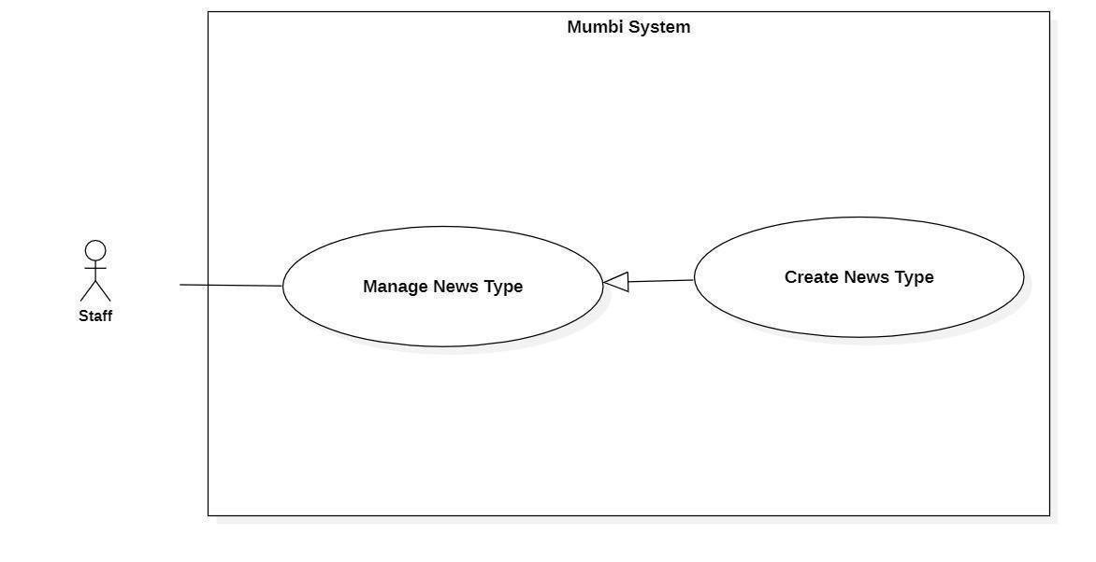

Figure 34 - <Staff>Create News Type

|  |  |  |  |
| --- | --- | --- | --- |
| **UC ID and Name:** | **Create News Type** | | |
| Created By: | Than Quoc Binh | Date Created: | 20/05/2021 |
| Primary Actor: | User | Secondary Actors: | N/A |
| Trigger: | The actor sends a request to create a news type. | | |
| Description: | The actor needs to have a news type to classify news. Therefore, this feature allows the staff to create news types. | | |
| Preconditions: | The actor had been authorized as a staff. | | |
| Post-conditions: | Success  A new news type is created.  Fail  The system shows an error message. | | |
| Normal Flow: | |  |  |  | | --- | --- | --- | | **Step** | **Actor Action** | **System Response** | | 1 | The actor sends a command to create a news type. | The system displays information of news type to create:   * Type | | 2 | The actor fills in information about the news type. | The system receives information, create a new news type. | | | |
| Alternative Flows: | N/A | | |
| Exceptions: | N/A | | |
| Priority: | Medium | | |
| Frequency of Use: | Frequently | | |
| Business Rules: | − Quy trình tạo loại tin tức:   * Điền thông tin cơ bản của loại tin tức. * Kiểm tra lại thông tin và gửi yêu cầu tạo một loại tin tức mới đến hệ thống.   − Loại cẩm nang bao gồm những trường sau:   * Loại cẩm nang   **\*English**  − The process of creating a news type:   * Fill in and select the basic information of the news type. * Check the information and send a request to create a new news type to the system.   − News type includes following fields:   * Type | | |
| Other Information: | N/A | | |
| Assumptions: | N/A | | |

Table 40 - <Staff> Create News Type

#### 2.4.14. Get News Type Detail

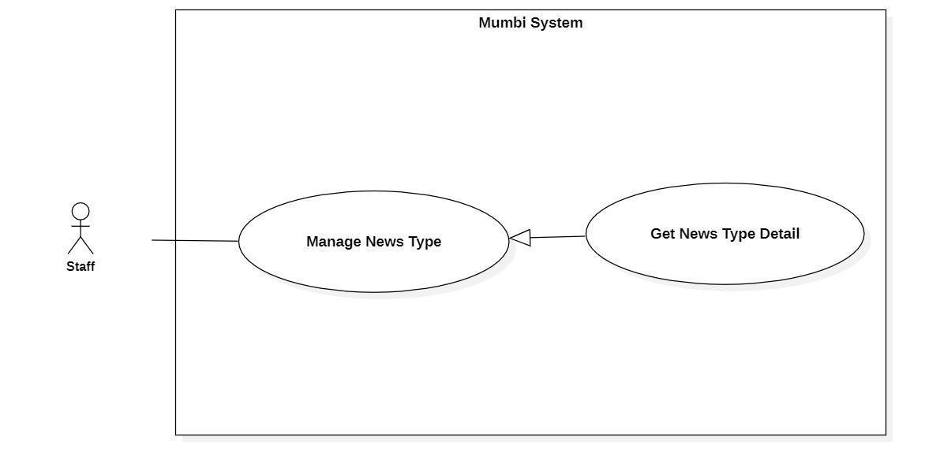

Figure 35 - <Staff> Get News Type Detail

|  |  |  |  |
| --- | --- | --- | --- |
| **UC ID and Name:** | **Get News Type Detail** | | |
| Created By: | Than Quoc Binh | Date Created: | 20/05/2021 |
| Primary Actor: | Staff | Secondary Actors: | N/A |
| Trigger: | The actor wants to get details of the news type. | | |
| Description: | This feature allows the actor to get detailed information of a news type. The staff uses this information to make sure that every information is accurate. | | |
| Preconditions: | The actor had been authorized as a staff. | | |
| Post-conditions: | Success  The actor receives details of news type.  Fail  N/A | | |
| Normal Flow: | |  |  |  | | --- | --- | --- | | **Step** | **Actor Action** | **System Response** | | 1 | The actor wants to get the details of the guidebook. | The system return detail of guidebook includes:   * Type | | | |
| Alternative Flows: | N/A | | |
| Exceptions: | N/A | | |
| Priority: | Medium | | |
| Frequency of Use: | Frequency | | |
| Business Rules: | - Hiển thị thông tin chi tiết của loại tin tức bao gồm:   * Loại tin tức   * English  − Display detail of news type includes:   * Type | | |
| Other Information: | N/A | | |
| Assumptions: | N/A | | |

Table 41 - <Staff> Get News Type Detail

#### 2.4.15. Update News Type Detail

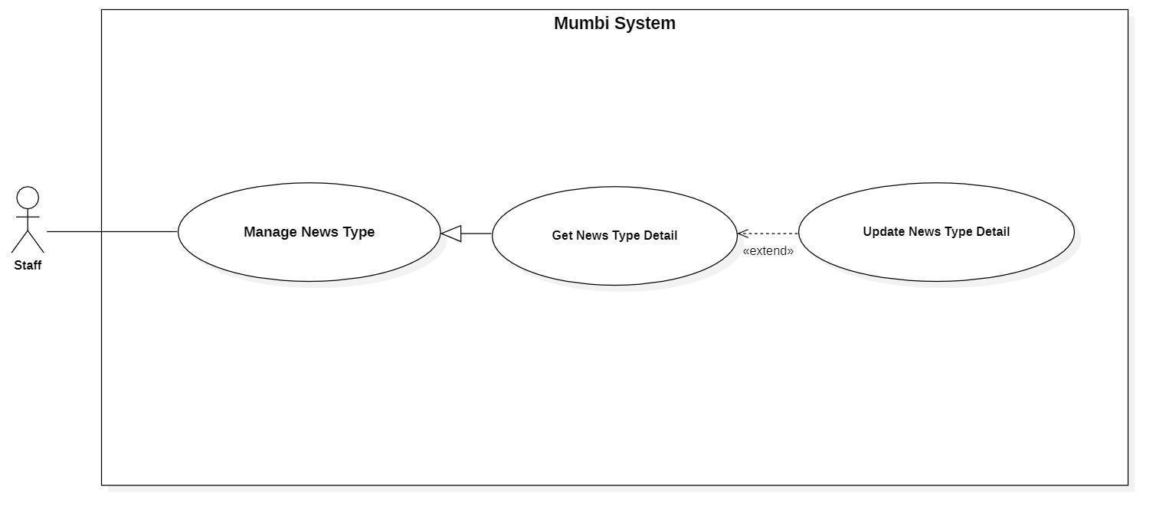

Figure 36 - <Staff> Update News Type Detail

|  |  |  |  |
| --- | --- | --- | --- |
| **UC ID and Name:** | **Update News Type Detail** | | |
| Created By: | Than Quoc Binh | Date Created: | 19/05/2021 |
| Primary Actor: | Staff | Secondary Actors: | N/A |
| Trigger: | The actor indicates to update the news type. | | |
| Description: | Sometimes, users want to edit information in news type. Therefore, this feature allows the actor to update the news type in detail. | | |
| Preconditions: | The actor had been authorized as a staff. | | |
| Post-conditions: | Success  The news type will be updated with new information.  Fail  The system shows an error message. | | |
| Normal Flow: | |  |  |  | | --- | --- | --- | | **Step** | **Actor Action** | **System Response** | | 1 | The actor sends a command to update the news type. | The system requests information of news type:   * Type | | 2 | The actor updates information of the news type.  The actor sends a request to update the news type. | The system updates the news type with this information. | | | |
| Alternative Flows: | N/A | | |
| Exceptions: | N/A | | |
| Priority: | Medium | | |
| Frequency of Use: | Rarely | | |
| Business Rules: | − Mỗi loại tin tức sẽ có thông tin và các thông tin trên có thể thay đổi theo thời gian. Vì vậy, nhân viên có thể cập nhật nó trên hệ thống.  − Thông tin của loại tin tức sẽ bao gồm những thông tin sau:   * Loại tin tức (Type):   **\*English**  − Each news type will have its own information and the above information may change over time. Therefore, the staff can update it on the system.  − The news type information will include the following information:   * Type (Type): | | |
| Other Information: | N/A | | |
| Assumptions: | N/A | | |

Table 42 - <Staff> Update News Type Detail

#### 2.4.16. Delete News Type

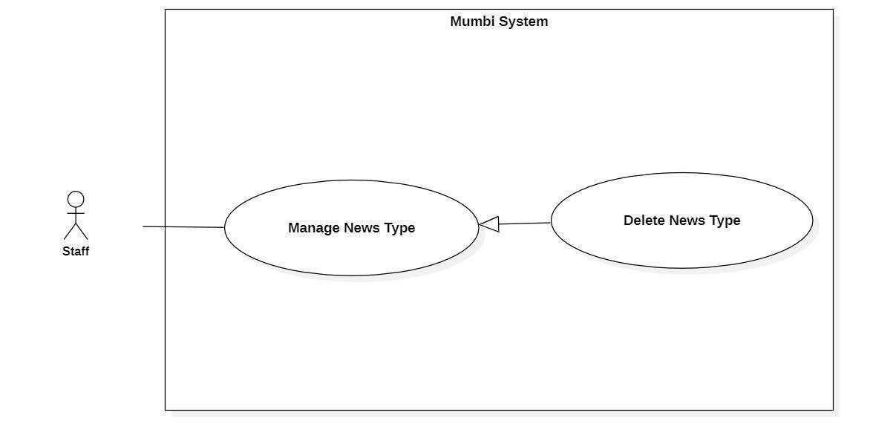

Figure 37 - <Staff> Delete News Type

|  |  |  |  |
| --- | --- | --- | --- |
| **UC ID and Name:** | **Delete News Type** | | |
| Created By: | Than Quoc Binh | Date Created: | 20/05/2021 |
| Primary Actor: | Staff | Secondary Actors: | N/A |
| Trigger: | The actor sends a request to delete the news type. | | |
| Description: | The actor needs to delete the news type from the system when it is no longer needed. Therefore, this feature allows the actor to delete the news type from the system. | | |
| Preconditions: | − The actor had been authorized as a staff. | | |
| Post-conditions: | Success  Send notification to the actor for deleting the news type and the selected news type will be hidden to the actor.  Fail  The system shows an error message. | | |
| Normal Flow: | |  |  |  | | --- | --- | --- | | **Step** | **Actor Action** | **System Response** | | 1 | The actor sends a command to delete the news type. | The system returns to the actor that the news type has been deleted. | | 2 | The actor sends a command to delete the news type. | The system changes the status of the news type. | | | |
| Alternative Flows: | N/A | | |
| Exceptions: | N/A | | |
| Priority: | Medium | | |
| Frequency of Use: | Rarely | | |
| Business Rules: | − Khi một loại tin tức không còn cần thiết nữa, nhân viên có thể xóa loại tin tức đó ra khỏi hệ thống.  − Sau khi một loại tin tức được xóa, nó sẽ được đổi trạng thái và nhân viên không còn nhìn thấy loại tin tức này.  **\*English**  − When a news type is no longer needed, the staff can delete that news type from the system.  − After a news type is deleted, it will be changed the status and the staff should no longer see this news type. | | |
| Other Information: | N/A | | |
| Assumptions: | N/A | | |

Table 43 - <Staff> Delete News Type

#### 2.4.17. Get User Detail

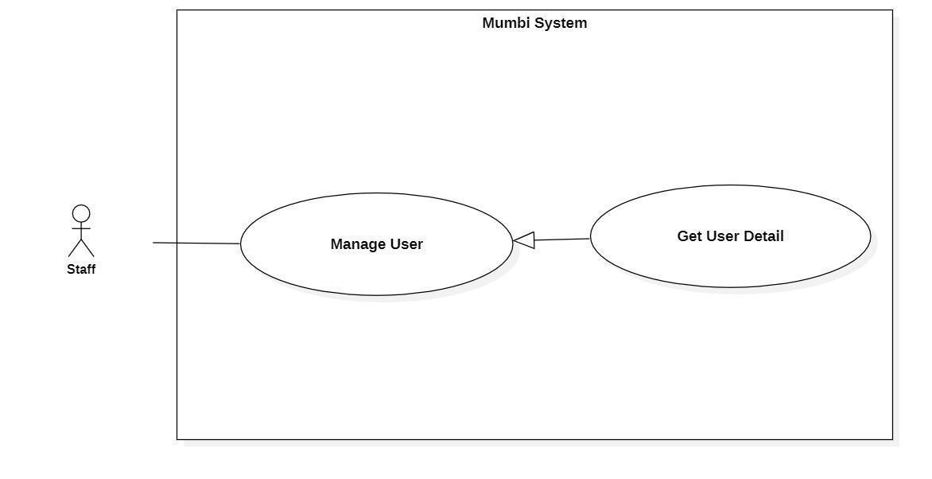

Figure 38 - <Staff> Get User Detail

|  |  |  |  |
| --- | --- | --- | --- |
| **UC ID and Name:** | **Get User Detail** | | |
| Created By: | Than Quoc Binh | Date Created: | 20/05/2021 |
| Primary Actor: | Staff | Secondary Actors: | N/A |
| Trigger: | The actor wants to get details of the user. | | |
| Description: | This feature allows the actor to get detailed information of a user including email, image, fullname. The staff uses this information to make sure that every information is accurate. | | |
| Preconditions: | The actor had been authorized as a staff. | | |
| Post-conditions: | Success  The actor receives details of the user.  Fail  N/A | | |
| Normal Flow: | |  |  |  | | --- | --- | --- | | **Step** | **Actor Action** | **System Response** | | 1 | The actor wants to get details of the user. | The system return detail of user includes:   * Fullname * Image * Email | | | |
| Alternative Flows: | N/A | | |
| Exceptions: | N/A | | |
| Priority: | Medium | | |
| Frequency of Use: | Frequency | | |
| Business Rules: | - Hiển thị thông tin chi tiết của người dùng bao gồm:   * Họ và tên * Hình ảnh * Email   * English  − Display detail of user includes:   * Fullname * Image * Email | | |
| Other Information: | N/A | | |
| Assumptions: | N/A | | |

Table 44 - <Staff> Get User Detail

#### 2.4.18. Update User Status

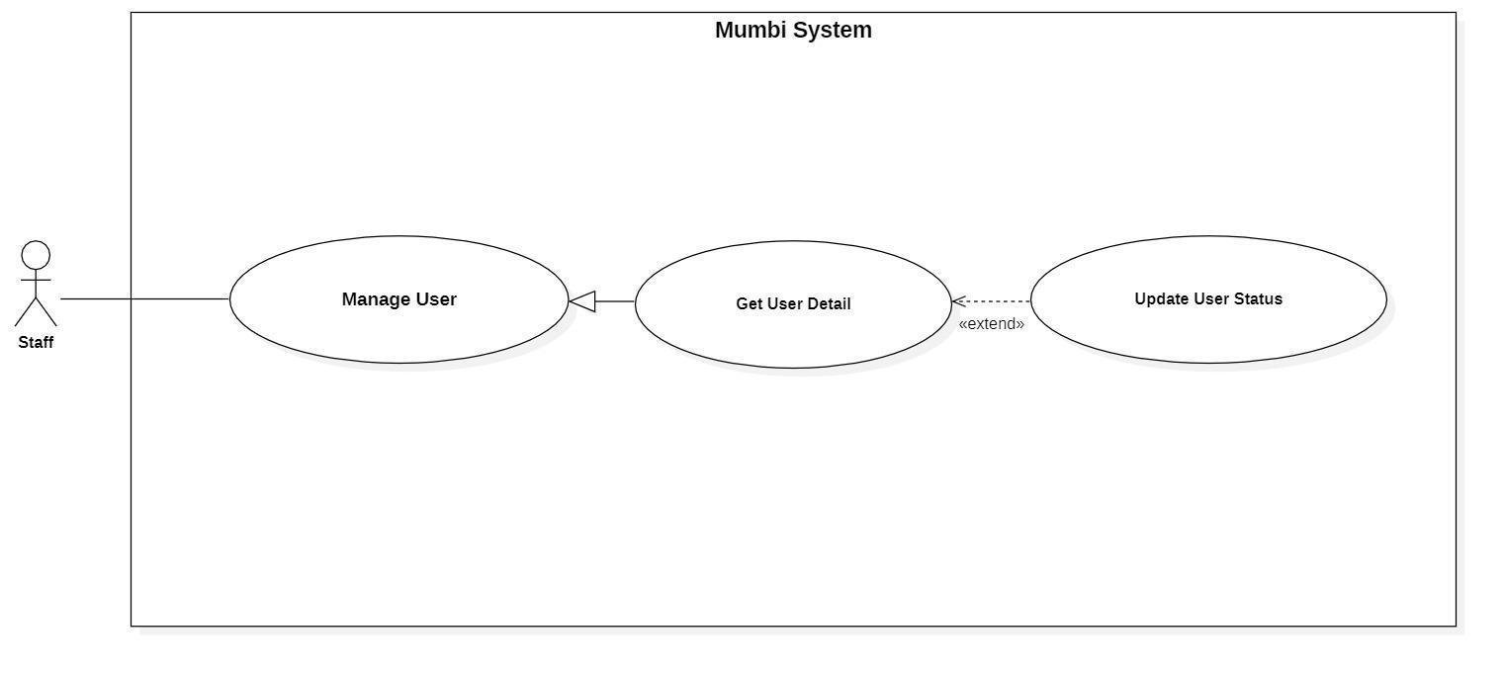

Figure 39 - <Staff> Update User Status

|  |  |  |  |
| --- | --- | --- | --- |
| **UC ID and Name:** | **Update User Status** | | |
| Created By: | Than Quoc Binh | Date Created: | 20/05/2021 |
| Primary Actor: | Staff | Secondary Actors: | N/A |
| Trigger: | The actor sends a request to update user status. | | |
| Description: | The actor needs to disable the user from the system. Therefore, this feature allows the actor to disable the user from the system. | | |
| Preconditions: | − The actor had been authorized as a staff. | | |
| Post-conditions: | Success  Send notification to the actor for disable user and the selected user will be hidden to the actor.  Fail  The system shows an error message. | | |
| Normal Flow: | |  |  |  | | --- | --- | --- | | **Step** | **Actor Action** | **System Response** | | 1 | The actor sends a command to disable the user. | The system returns to the actor that user has been disabled. | | 2 | The actor sends a command to disable the user. | The system changes the status of the user. | | | |
| Alternative Flows: | N/A | | |
| Exceptions: | N/A | | |
| Priority: | Medium | | |
| Frequency of Use: | Rarely | | |
| Business Rules: | − Sau khi một người dùng bị vô hiệu hóa, người dùng sẽ được đổi trạng thái không được đăng nhập vào hệ thống và nhân viên không còn nhìn thấy người dùng này.  **\*English**  − After a user is disabled, the user will be changed to not logged in to the system and staff will no longer see this user. | | |
| Other Information: | N/A | | |
| Assumptions: | N/A | | |

Table 45 - <Staff> Update User Status

#### 2.4.19. Approve Post

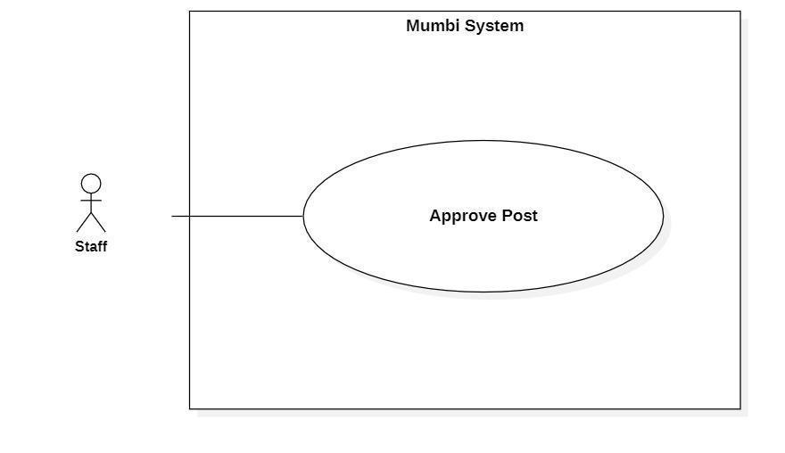

Figure 40 - <Staff> Approve Post

|  |  |  |  |
| --- | --- | --- | --- |
| **UC ID and Name:** | **Approve Post** | | |
| Created By: | Than Quoc Binh | Date Created: | 20/05/2021 |
| Primary Actor: | Staff | Secondary Actors: | N/A |
| Trigger: | The actor sends a request to approve the post. | | |
| Description: | The actor needs to approve the post when the user wants to publish a diary to the community. Therefore, this feature allows the actor to approve posts the user wants to publicize. | | |
| Preconditions: | − The actor had been authorized as a staff. | | |
| Post-conditions: | Success  The diary will be published to the community.  Fail  N/A | | |
| Normal Flow: | |  |  |  | | --- | --- | --- | | **Step** | **Actor Action** | **System Response** | | 1 | The actor sends a command to approve the post. | The system returns to the actor that the post has been published. | | | |
| Alternative Flows: | N/A | | |
| Exceptions: | N/A | | |
| Priority: | Medium | | |
| Frequency of Use: | Rarely | | |
| Business Rules: | − Sau khi một nhật ký được phê duyệt, nó sẽ được hiển thị trên mục cộng đồng trên mobile và nhân viên không còn nhìn thấy nhật ký này.  **\*English**  − After a diary is approved, it will be displayed in the community on a mobile app and the staff should no longer see this diary. | | |
| Other Information: | N/A | | |
| Assumptions: | N/A | | |

Table 46 - <Staff> Approve Post

#### 2.4.20. Create Activity

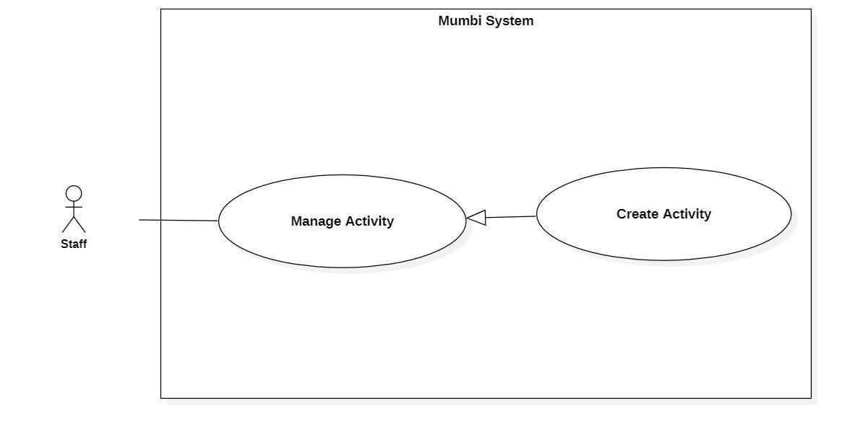

Figure 41 - <Staff> Create Activity

|  |  |  |  |
| --- | --- | --- | --- |
| **UC ID and Name:** | **Create Activity** | | |
| Created By: | Than Quoc Binh | Date Created: | 20/05/2021 |
| Primary Actor: | User | Secondary Actors: | N/A |
| Trigger: | The actor sends a request to create an activity. | | |
| Description: | The actor needs to create activity for users to get activity to help their children develop better. Therefore, this feature allows the staff to create activity. | | |
| Preconditions: | The actor had been authorized as a staff. | | |
| Post-conditions: | Success  A new activity is created.  Fail  The system shows an error message. | | |
| Normal Flow: | |  |  |  | | --- | --- | --- | | **Step** | **Actor Action** | **System Response** | | 1 | The actor sends a command to create an activity. | The system displays information of activity to create:   * ActivityName * MediaFile * Type * SuitableAge | | 2 | The actor fills in information about the activity. | The system receives information, create a new activity. | | | |
| Alternative Flows: | N/A | | |
| Exceptions: | N/A | | |
| Priority: | Medium | | |
| Frequency of Use: | Frequently | | |
| Business Rules: | − Quy trình tạo hoạt động:   * Điền thông tin cơ bản của hoạt động. * Kiểm tra lại thông tin và gửi yêu cầu tạo một hoạt động mới đến hệ thống.   − Hoạt động bao gồm những trường sau:   * Tên hoạt động * File âm thanh * Loại hoạt động * Độ tuổi phù hợp   - Loại hoạt động bao gồm: Nghe nhạc, Kể chuyện, Đọc thơ  **\*English**  − The process of creating a activity:   * Fill in and select the basic information of the activity. * Check the information and send a request to create a new activity to the system.   − Activity includes following fields:   * ActivityName * MediaFile * Type * SuitableAge   - Type of action includes: listening music, telling story, reading poetry | | |
| Other Information: | N/A | | |
| Assumptions: | N/A | | |

Table 47 - <Staff> Create Activity

#### 2.4.21. Get Activity Detail

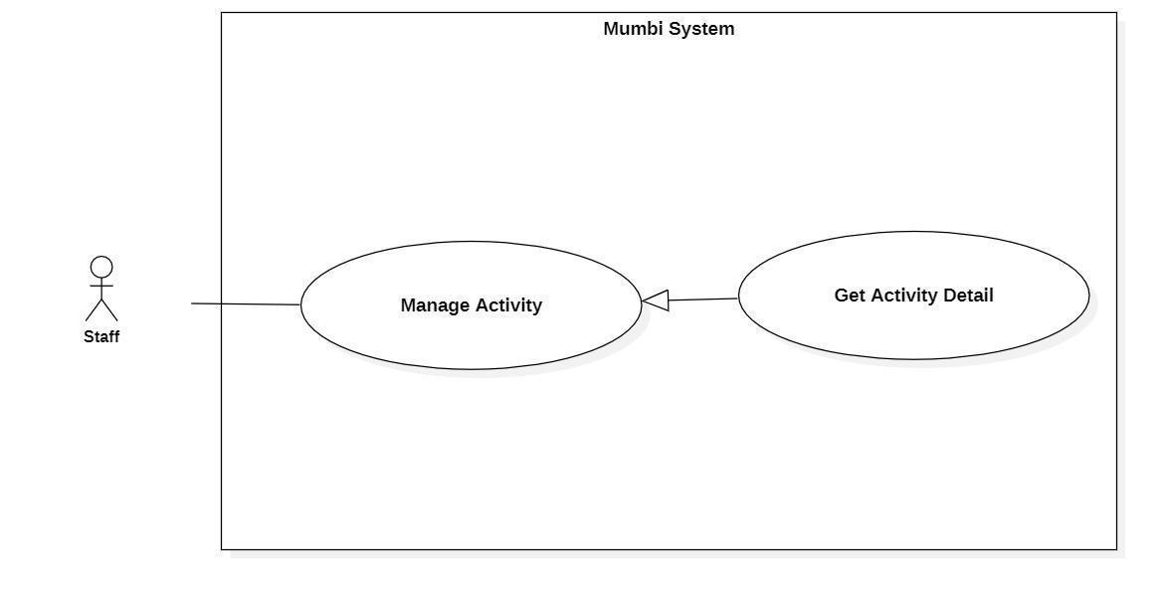

Figure 42 - <Staff> Get Activity Detail

|  |  |  |  |
| --- | --- | --- | --- |
| **UC ID and Name:** | **Get Activity Detail** | | |
| Created By: | Than Quoc Binh | Date Created: | 20/05/2021 |
| Primary Actor: | Staff | Secondary Actors: | N/A |
| Trigger: | The actor wants to get details of the activity. | | |
| Description: | This feature allows the actor to get detailed information of an activity. The staff uses this information to make sure that every information is accurate. | | |
| Preconditions: | The actor had been authorized as a staff. | | |
| Post-conditions: | Success  The actor receives details of activity.  Fail  N/A | | |
| Normal Flow: | |  |  |  | | --- | --- | --- | | **Step** | **Actor Action** | **System Response** | | 1 | The actor wants to get details of the activity. | The system return detail of activity includes:   * ActivityName * MediaFile * Type * SuitableAge | | | |
| Alternative Flows: | N/A | | |
| Exceptions: | N/A | | |
| Priority: | Medium | | |
| Frequency of Use: | Frequency | | |
| Business Rules: | - Hiển thị thông tin chi tiết của hoạt động bao gồm:   * Tên hoạt động * File âm thanh * Loại hoạt động * Độ tuổi phù hợp   * English  − Display detail of activity includes:   * ActivityName * MediaFile * Type * SuitableAge | | |
| Other Information: | N/A | | |
| Assumptions: | N/A | | |

Table 48 - <Staff> Get Activity Detail

#### 2.4.22. Update Activity Detail

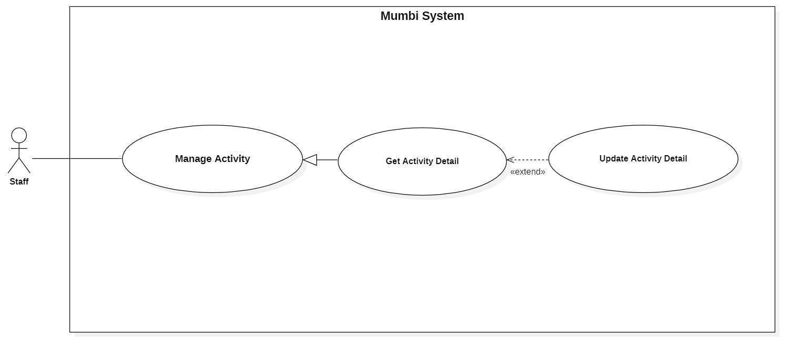

Figure 43 - <Staff> Update Activity Detail

|  |  |  |  |
| --- | --- | --- | --- |
| **UC ID and Name:** | **Update Activity Detail** | | |
| Created By: | Than Quoc Binh | Date Created: | 19/05/2021 |
| Primary Actor: | Staff | Secondary Actors: | N/A |
| Trigger: | The actor indicates to update activity. | | |
| Description: | Sometimes, users want to edit information in an activity. Therefore, this feature allows the actor to update the activity detail. | | |
| Preconditions: | The actor had been authorized as a staff. | | |
| Post-conditions: | Success  The activity will be updated with new information.  Fail  The system shows an error message. | | |
| Normal Flow: | |  |  |  | | --- | --- | --- | | **Step** | **Actor Action** | **System Response** | | 1 | The actor sends a command to update activity. | The system requests information of activity:   * ActivityName * MediaFile * Type * SuitableAge | | 2 | The actor updates information about the activity.  The actor sends a request to update activity. | The system updates the activity with this information. | | | |
| Alternative Flows: | N/A | | |
| Exceptions: | N/A | | |
| Priority: | Medium | | |
| Frequency of Use: | Rarely | | |
| Business Rules: | − Mỗi hoạt động sẽ có thông tin và các thông tin trên có thể thay đổi theo thời gian. Vì vậy, nhân viên có thể cập nhật nó trên hệ thống.  − Thông tin của hoạt động sẽ bao gồm những thông tin sau:   * Tên hoạt động * File âm thanh * Loại hoạt động * Độ tuổi phù hợp   **\*English**  − Each activity will have its own information and the above information may change over time. Therefore, the staff can update it on the system.  − The activity information will include the following information:   * ActivityName * MediaFile * Type * SuitableAge | | |
| Other Information: | N/A | | |
| Assumptions: | N/A | | |

Table 49 - <Staff> Update Activity Detail

#### 2.4.23. Delete Activity

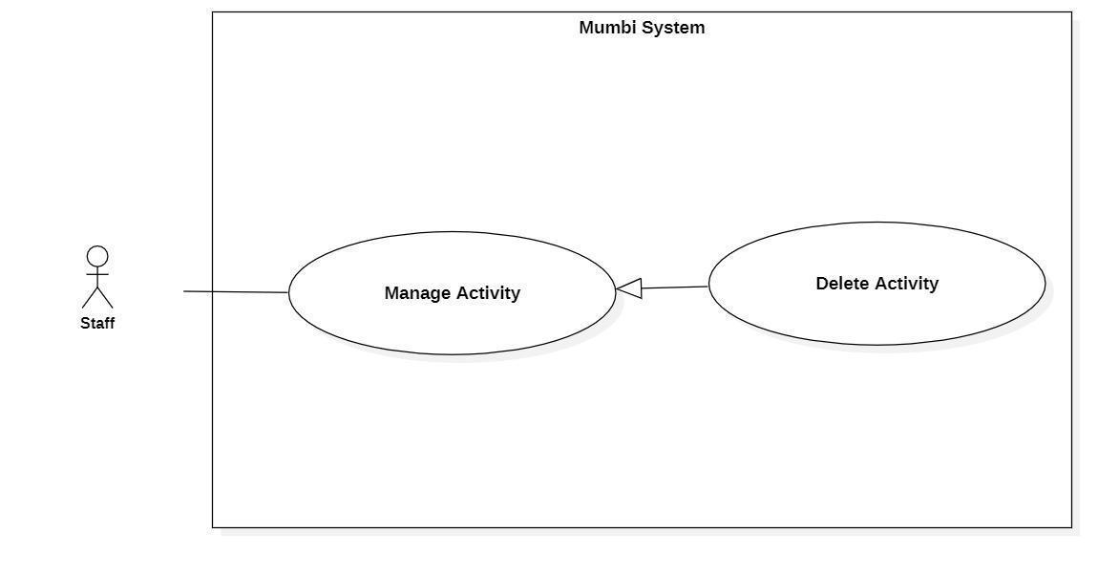

Figure 44 - <Staff> Delete Activity

|  |  |  |  |
| --- | --- | --- | --- |
| **UC ID and Name:** | **Delete Activity** | | |
| Created By: | Than Quoc Binh | Date Created: | 20/05/2021 |
| Primary Actor: | Staff | Secondary Actors: | N/A |
| Trigger: | The actor sends a request to delete activity. | | |
| Description: | The actor needs to delete the activity from the system when it is no longer needed. Therefore, this feature allows the actor to delete the activity from the system. | | |
| Preconditions: | − The actor had been authorized as a staff. | | |
| Post-conditions: | Success  Send notification to the actor for deleting activity and the selected action will be hidden to the actor.  Fail  The system shows an error message. | | |
| Normal Flow: | |  |  |  | | --- | --- | --- | | **Step** | **Actor Action** | **System Response** | | 1 | The actor sends a command to delete the activity. | The system returns to the actor that activity has been deleted. | | 2 | The actor sends a command to delete the activity. | The system changes the status of the activity. | | | |
| Alternative Flows: | N/A | | |
| Exceptions: | N/A | | |
| Priority: | Medium | | |
| Frequency of Use: | Rarely | | |
| Business Rules: | − Khi một hoạt động không còn cần thiết nữa, nhân viên có thể xóa hoạt động đó ra khỏi hệ thống.  − Sau khi một hoạt động được xóa, nó sẽ được đổi trạng thái và nhân viên không còn nhìn thấy loại tin tức này.  **\*English**  − When an activity is no longer needed, the staff can delete that activity from the system.  − After an activity is deleted, the status will be changed and the staff should no longer see this activity. | | |
| Other Information: | N/A | | |
| Assumptions: | N/A | | |

Table 50 - <Staff> Delete Activity

### 2.5. Firebase Service

#### 2.5.1. Verify Phone number

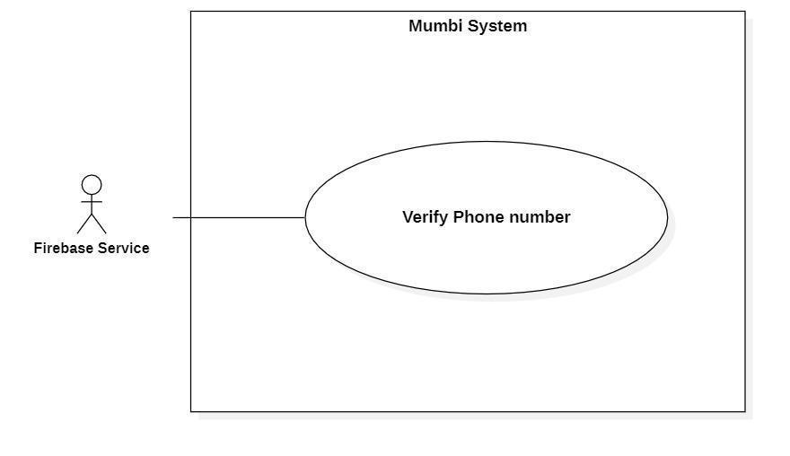

Figure 45 - <Firebase Service> Verify Phone number

|  |  |  |  |
| --- | --- | --- | --- |
| **UC ID and Name:** | **Verify Phone number** | | |
| Created By: | Bui Hai Nam | Date Created: | 20/05/2021 |
| Primary Actor: | Firebase Service | Secondary Actors: | N/A |
| Trigger: | The actor receives a request to verify the phone number. | | |
| Description: | In Mumbi, the phone number of the user is required information and it must be verified that the user is the owner. So, Mumbi can get vaccine schedules for its users. | | |
| Preconditions: | The system has received the phone number that needs to be verified. | | |
| Post-conditions: | Success  The phone number is verified.  Fail  The phone number is not verified. | | |
| Normal Flow: | |  |  |  | | --- | --- | --- | | **Step** | **Actor Action** | **System Response** | | 1 | The actor requests a phone  number. | The system sends a request to verify a phone number. | | 2 | The actor receives the phone number.  The actor sends an OTP to the phone number.  The actor requires OTP from the system. | The system sends the phone number. | | 3 | The actor receives an OTP and checks it.  [Exception 1]  [Exception 2]  When the OTP is matched, the actor returns a success message to the system. | The system sends an OTP to the actor. | | 4 |  | The system receives messages and marks that the phone number is verified. | | | |
| Alternative Flows: | N/A | | |
| Exceptions: | |  |  |  | | --- | --- | --- | | **No** | **Cause** | **System Response** | | 1 | The OTP is not matched. | The system shows error  messages and requests another OTP. | | 2 | The OTP is due. | The system shows error  messages and requests to re-verify the phone number. | | | |
| Priority: | High | | |
| Frequency of Use: | Regularly | | |
| Business Rules: | − Số điện thoại được xác thực theo cách sau:   * Firebase tiến hành gửi một mã OTP đến số điện thoại cần xác minh. * Người dùng nhập mã này vào hệ thống. * Hệ thống gửi mã này cho Firebase để xác thực. * Nếu mã khớp và còn thời hạn, Firebase gửi thông báo thành công về cho hệ thống. Hệ thống đánh dấu rằng số điện thoại đã được xác thực.   **\*English:**  − Phone numbers are authenticated in the following way:   * Firebase proceeds to send an OTP to the phone number to be verified. * The user enters this code into the system. * The system sends this code to Firebase for authentication. * If the code matches and is still valid, Firebase sends a notification of success to the system. The system marks that the phone number is authenticated. | | |
| Other Information: | N/A | | |
| Assumptions: | N/A | | |

Table 51 - <Firebase System> Verify Phone number

## 3. Functional Requirements

## 3.1. Conceptual Diagram

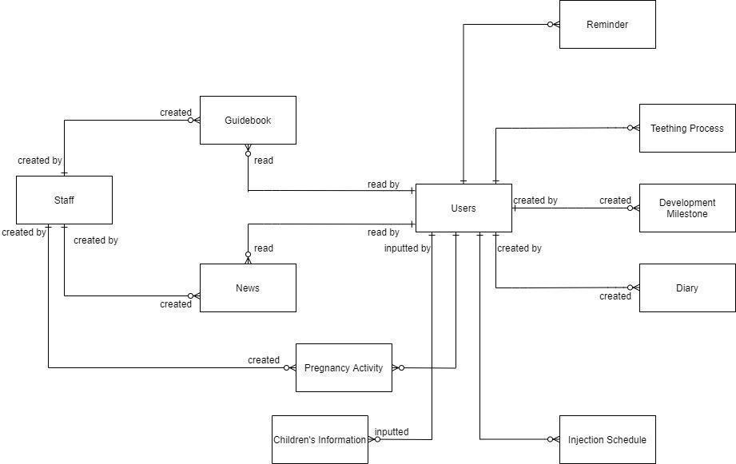

Figure 46 - Conceptual Diagram

## 3.2. Entity Relationship Diagram

Source: [Entity Relationship Diagram](https://drive.google.com/file/d/1RTuNC6RFOYgKLLUqF1Tg3YA8RemvNqIC/view?usp=sharing)

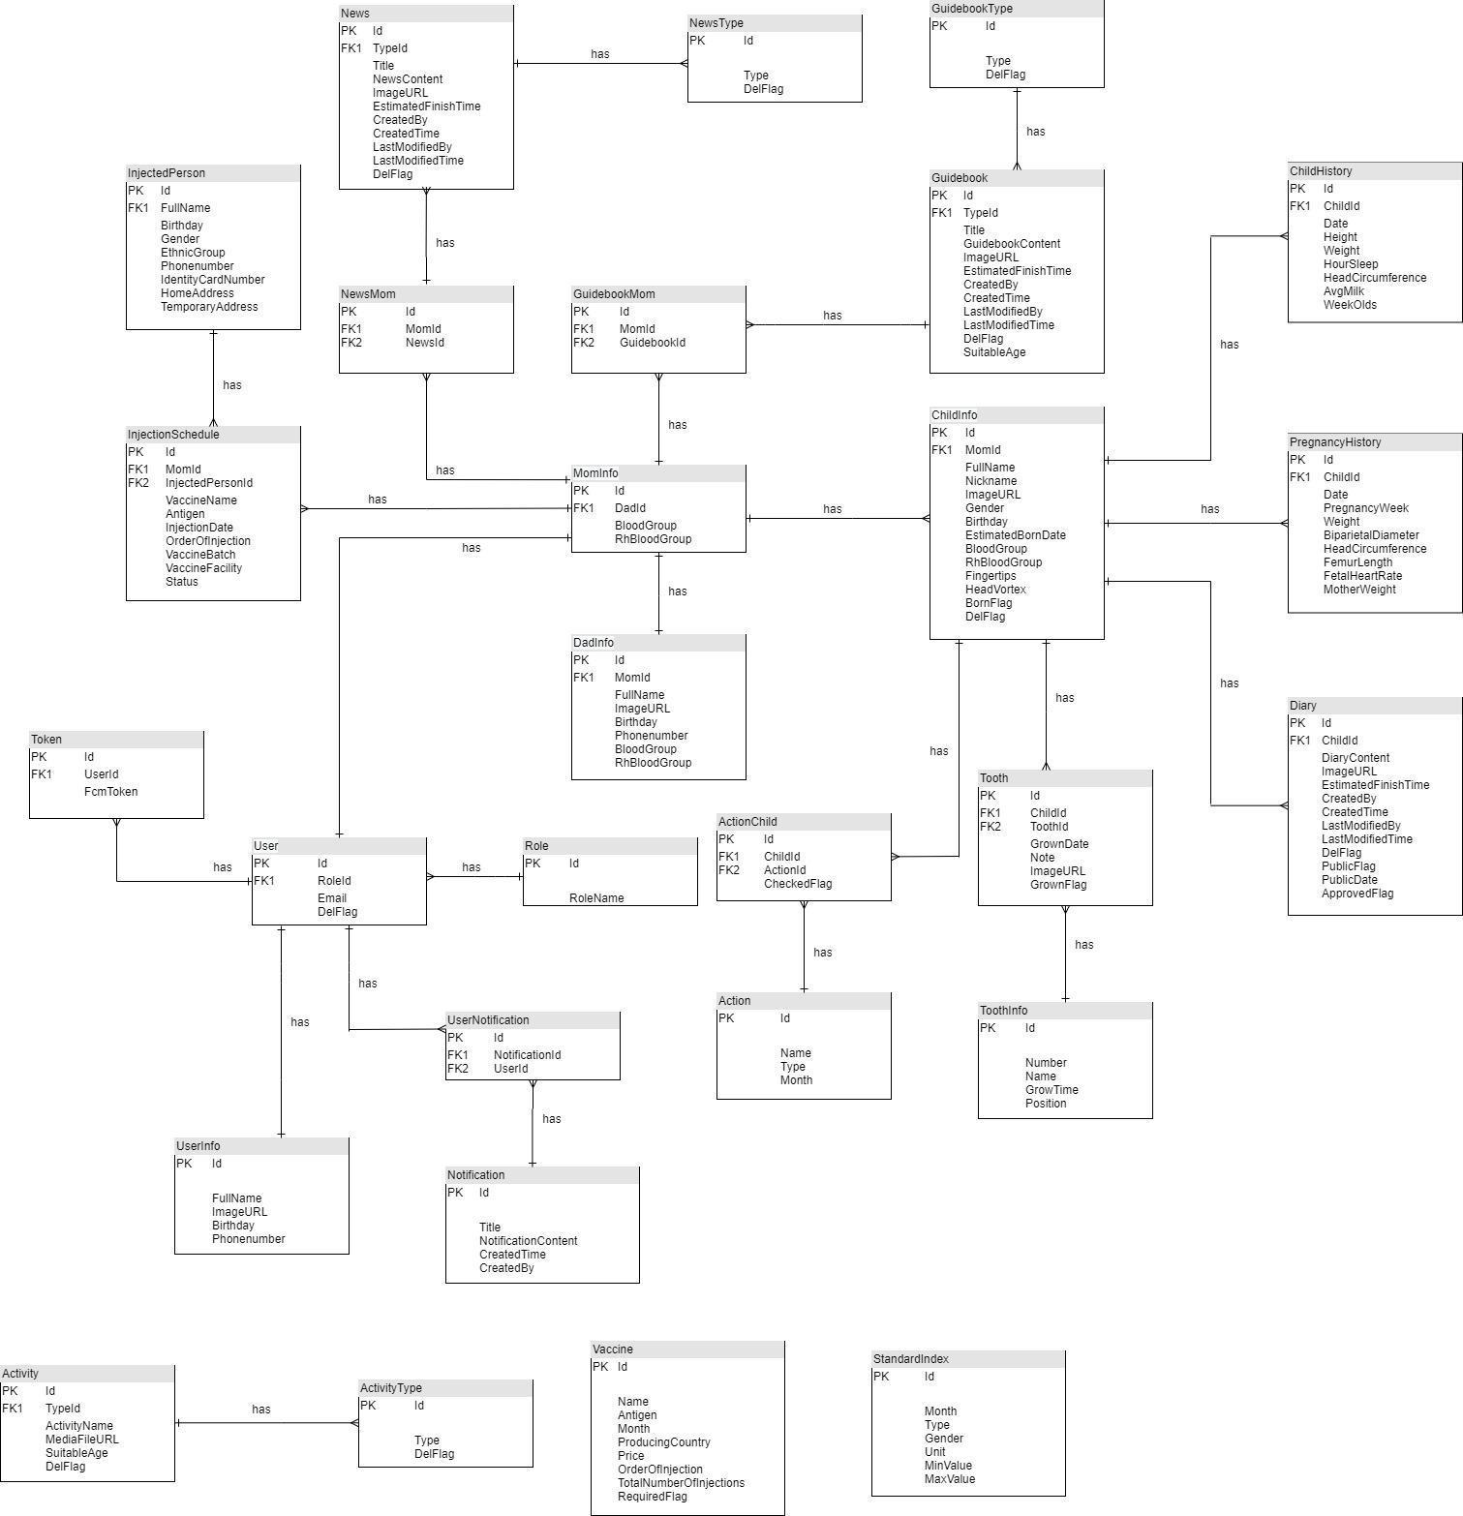

Figure 47 - Entity Relationship Diagram

|  |  |  |
| --- | --- | --- |
| **No** | **Entity** | **Description** |
| 1 | MomInfo | Contain information of mom |
| 2 | DadInfo | Contain information of dad |
| 3 | GuidebookMom | Contain guidebook is saved |
| 4 | Guidebook | Contain information of guidebook |
| 5 | GuidebookType | Contain type of guidebook |
| 6 | NewsMom | Contain news is saved |
| 7 | News | Contain information of news |
| 8 | NewsType | Contain type of news |
| 9 | Diary | Contain information of diary |
| 10 | ChildHistory | Contain information of child history |
| 11 | PregnancyHistory | Contain information of pregnancy history |
| 12 | Tooth | Contain all tooth |
| 13 | ToothInfo | Contain information of tooth |
| 14 | Action | Contain information of action |
| 15 | ActionChild | Contain action child |
| 16 | User | Contain user in system |
| 17 | Role | Contain role in system |
| 18 | UserNotification | Contain user notification |
| 19 | Notification | Contain information of notification |
| 20 | UserInfo | Contain information of user |
| 21 | Token | Contain information of token |
| 22 | InjectedPerson | Contain information of injected person |
| 23 | InjectionSchedule | Contain information of injection schedule |
| 24 | Activity | Contain information of activity |
| 25 | ActivityType | Contain type of activity |
| 26 | Vaccine | Contain information of vaccine |
| 27 | StandardIndex | Contain information of standard index |

Table 52 - Entity Data Dictionary

## 3.3 System Functional Overview

### 3.3.1 Screen Flow

#### 3.3.1.1 Customer application

Figure 48 - <Customer application> Screen flow

#### 3.3.1.2. Staff application

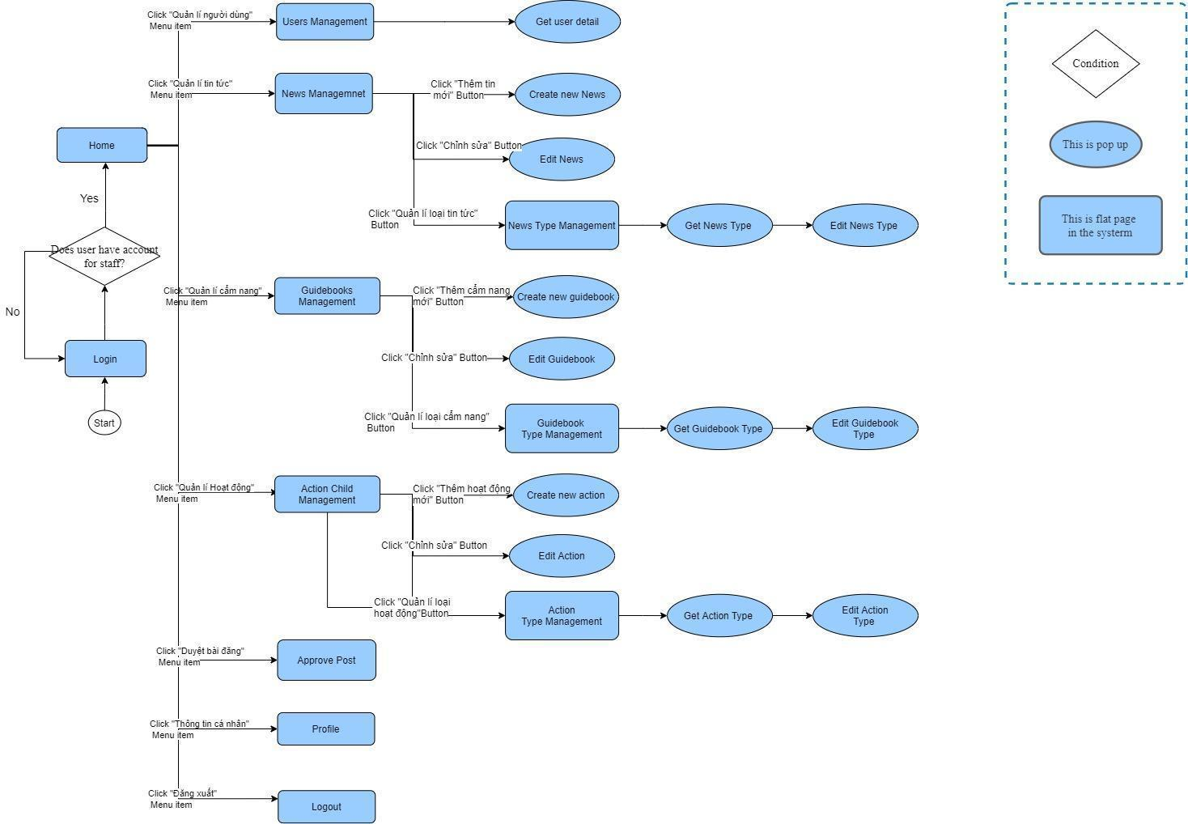

Figure 49 - <Staff application> Screen flow

### 3.3.2 Screen details

#### 3.3.2.1 Customer application

|  |  |  |  |
| --- | --- | --- | --- |
| **Id** | **Feature** | **Screen** | **Description** |
|  | Login | **Login page** | Login to system with customer role |
|  | Home | **Home main page** | View the overall of the homepage with customer role |
|  | Get guidebook | **Guidebook page** | Get full of guidebook in the system |
|  | Get baby’s development | **Baby tracker page** | Get the development detail of baby from system |
|  | Get baby’s Injection Schedule | **Injection Schedule page** | Get the Injection Schedule of baby from system |
|  | Community | **Community page** | View a list of your baby's diary |
|  | View baby’s development milestones | **Development milestones page** | View baby’s development milestones from system |
|  | View News | **News page** | View full of News in the system |
|  | Save Guidebooks | **Save Guidebooks page** | Save Guidebooks in system with customer role |
|  | Update Data Baby | **Update Data Baby page** | Update the data of baby regularly in system |
|  | Select pregnancy activity | **Select pregnancy activity page** | Select a type of customer’s pregnancy activity from system |
|  | View family members | **My Family page** | View members in customer’s family from data typed in the system |
|  | View savings | **Saving page** | View full of customer savings |
|  | Get diary | **Diary page** | View full of customers diary |
|  | View Growing teeth | **Teeth Grow page** | View and update data teeth |
|  | Contact Help | **Contact Help page** | Contact to be supported in the process customer using application |
|  | Logout | **Logout page** | Logout of system |
|  | Save News | **Save News page** | Save News in system with customer role |
|  | Create Data Father | **Create Data Father page** | Create Data Father in system with customer role |
|  | Create Data Baby | **Create Data Baby page** | Create Data baby in system with customer role |
|  | View saving guidebooks | **Saving Guidebooks page** | View customer’s saving Guidebooks in system |
|  | View saving news | **Saving News page** | View customer’s saving News in system |
|  | Create a Diary | **Create a Diary page** | Create a Diary in system with customer role |
|  | Create Data Tooth | **Create Data Tooth page** | Create baby’s Data tooth in system with customer role |
|  | Get growing teeth process | **Teeth Grow Process page** | View Timeline data of Growing Teeth |
|  | Update Phone Number | **Update Phone Number page** | Update customer’s phone number in system |
|  | Get Injection Schedule Detail | **Injection Schedule Detail page** | Get the Injection Schedule Detail of baby from system |
|  | Compare Vaccine | **Compare Vaccine page** | View list of vaccines |
|  | Save a diary | **Save a diary page** | Save a customer’s diary in system |
|  | Post on forum | **Post on forum page** | Give a post on forum in system |
|  | View Vaccination date | **Vaccination date page** | View full of Vaccination date from system |
|  | Get Standard Index | **Standard Index page** | Get baby’s Standard Index in system |
|  | Get Fine Motor Skills | **Fine Motor Skills page** | Get baby’s Fine Motor Skills in system |
|  | Get Gross Motor Skills | **Gross Motor Skills page** | Get baby’s Gross Motor Skills in system |
|  | Input OTP Token | **Input OTP Token page** | Input number of OTP Token of phone number |
|  | Update baby’s Fine Motor Skills | **Update baby’s Fine Motor Skills page** | Update baby’s Fine Motor Skills in system |
|  | Update baby’s Gross Motor Skills | **Update baby’s Gross Motor Skills page** | Update baby’s Gross Motor Skills in system |
|  | Input Password | **Input Password page** | Input password of phone number |
|  | Register Account | **Register Account page** | Fill in customer information to register Account in system |

Table 53 - <Customer application> Screen details

#### 3.2.2.2 Staff application

|  |  |  |  |
| --- | --- | --- | --- |
| **Id** | **Feature** | **Screen** | **Description** |
|  | Login | **Login page** | Login to system with staff role |
|  | View overall | **Home page** | View the overall of the homepage with staff role |
|  | Manage user | **User Management page** | Manage all of user in system |
|  | Manage News | **News Management page** | Manage all of News in system |
|  | Manage Guidebooks | **Guidebooks Management page** | Manage all of Guidebooks in system |
|  | Manage Action Child | **Action Child Management page** | Manage all of Action Child in system |
|  | Approve Post | **Approve Post page** | Check and approve customer’s Post |
|  | Get profile | **Profile page** | Get information of staff from system |
|  | Logout | **Logout page** | Logout of system with the role as staff |
|  | Get user detail | **Get user detail page** | Get information detail of user from system |
|  | Create new News | **Create new News page** | Create new News in system |
|  | Edit News | **Edit News page** | Edit News in system |
|  | Manage News Type | **News Type Management page** | Manage News Type in system |
|  | Create new action | **Create new action page** | Create new action in system |
|  | Edit Action | **Edit Action page** | Edit full of action in system |
|  | Manage Action Type | **Action Type Management page** | Manage all type of Action in system |
|  | Get News Type | **Get News Type page** | Get the type of News from system |
|  | Get Guidebook Type | **Get Guidebook Type page** | Get the type of Guidebook from system |
|  | Get Action Type | **Get Action Type page** | Get the type of Action from system |
|  | Edit News Type | **Edit News Type page** | Edit News Type in system |
|  | Edit Guidebook Type | **Edit Guidebook Type page** | Edit Guidebook Type in system |
|  | Edit Action Type | **Edit Action Type page** | Edit Action Type in system |

Table 54 - <Staff application> Screen details

# 4. Non-Functional Requirements

## 4.1. External Interfaces

### 4.1.1. User Interfaces

* Both the web application and mobile application user interface will be Vietnamese.

### 4.1.2. Software Interfaces

* Mobile Application: Android Operating System v10.0.
* Web Application:
* Chrome browser, Firefox browser.
* Browsers support HTML5, CSS3 and have Javascript enabled.

### 4.1.3. Communication Interfaces

* Authentication service: The system can be integrated with Firebase Authentication.
* File Storage Service: The system can be integrated with Firebase Storage.
* The system can use HTTP to transfer data.

## 4.2. Quality Attributes

### 4.2.1. Usability

* All texts, labels and messages should be written in Vietnamese.
* The web application for staff should require no more than one day of training to be used.
* It takes Customer about 10-20 minutes to get acquainted and use the app.

### 4.2.2. Reliability

* The application should handle HTTP/HTTPS requests in less than 10 seconds at any time.

### 4.2.3. Portability

* The user’s software is a mobile application.
* The staff and doctor’s software is a web-based application.
* The applications are working well in Chrome Browser version 65 and higher.

### 4.2.4. Security

* In order to access the application User and Staff must be authenticated by logging using their Gmail account.
* Mumbi system is currently divided into 2 roles: Users, Staffs.
* All input data are validated before saving to the database.
* Each role only accesses a group of functions.
* The system always checks for authorization and authentication before doing any features.